PROJECT TITLE:

Medical Inventory Management System

**College Name**: VET INSTITUTE OF ARTS AND SCIENCE

**College Code**: 65651

**TEAM ID**: NM2025TMID25772

**TEAM MEMBERS**:

**Team Leader:** Lakisha Bothra

**Email:** lakishabothra23csa@vetias.ac.in

**Team Member:** Jeevan kumar

**Email:** jeevankumar23csa@vetias.ac.in

**Team Member:** Logeshwari

**Email:** logeshwarik23csa@vetias.ac.in

**Team Member:** Rohit Pranav Devaraj

**Email:** rohitpranavdevaraj23csa@vetias.ac.in

**Team Member:** Suman D

**Email:** sumand23csa@vetias.ac.in

**1.INTRODUCTION**

**1.1 Project Overview :**

The **Medical Inventory Management System** is a Salesforce-based digital application designed to manage and track medical supplies, medicines, and equipment efficiently. It ensures hospitals, pharmacies, and clinics maintain accurate stock levels, monitor expiry dates, and streamline the process of procurement and distribution.

The system allows administrators to add, update, and monitor stock, set reorder levels, generate real-time inventory reports, and receive automated alerts for low stock or expired items. This improves patient safety and helps healthcare organizations maintain compliance.

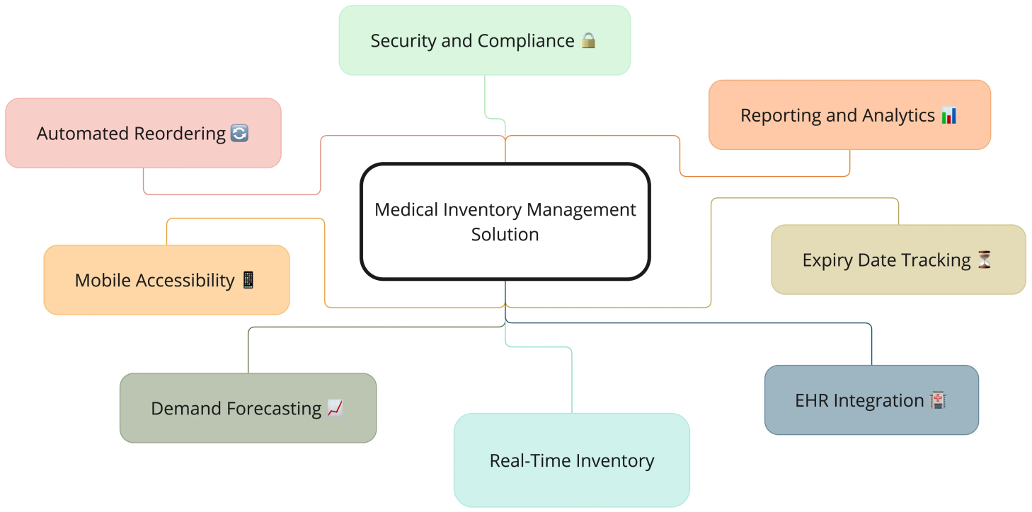

**1.2 Purpose :**

The main objective of this project is to:

* Ensure **accurate stock management** of medicines and equipment.
* Minimize **wastage due to expired items**.
* Automate **purchase requests** when stock reaches threshold levels.
* Provide **real-time transparency** for healthcare providers.
* Enhance patient safety by ensuring **availability of essential medicines**.

**DEVELOPMENT PHASE:**

**Creating Developer Account:**

By using this URL – https://www.salesforce.com/form/delveloper-signup/?d=pd

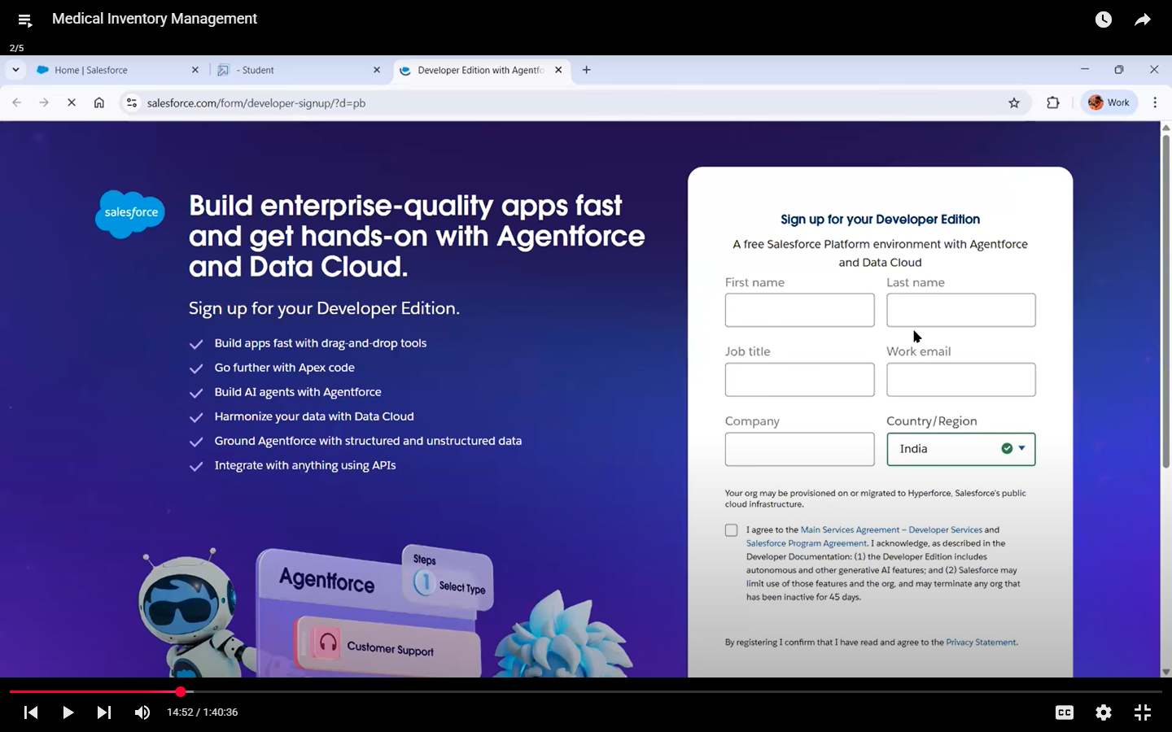

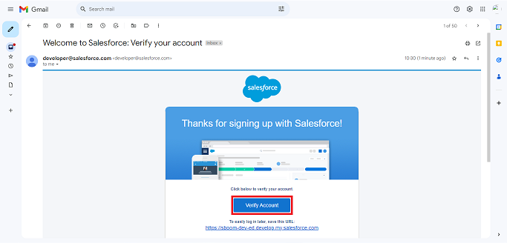





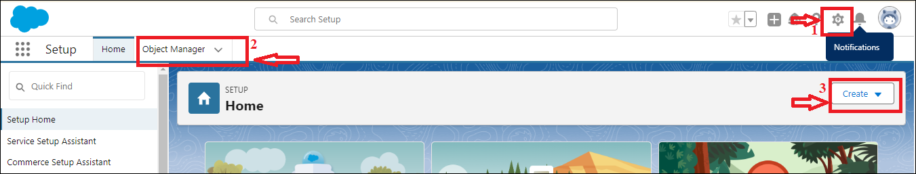

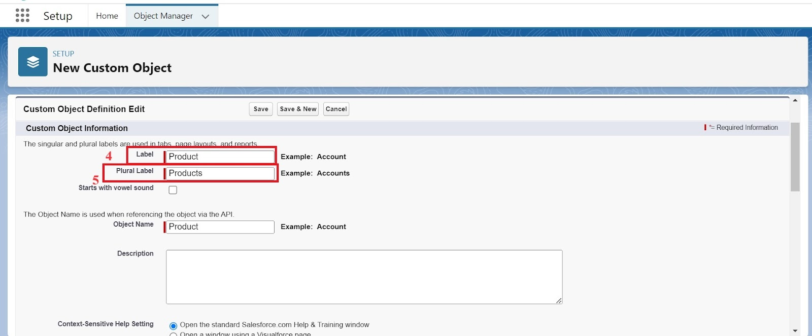

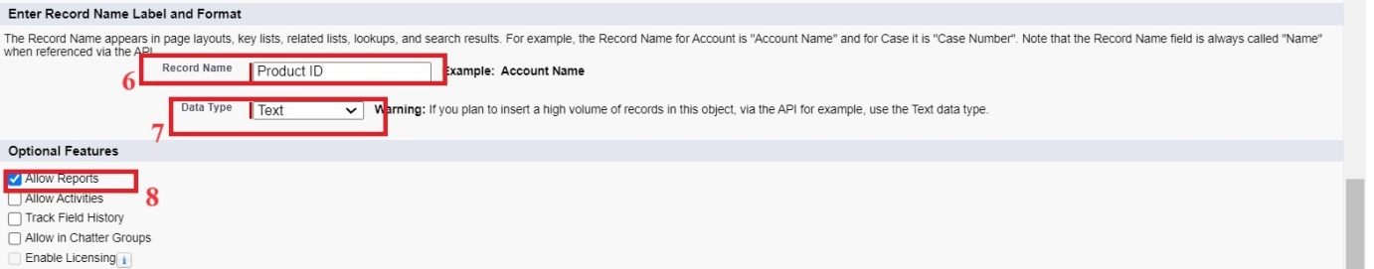

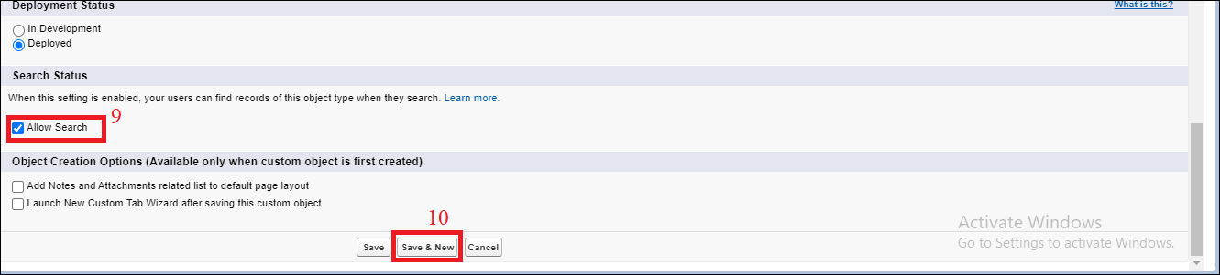

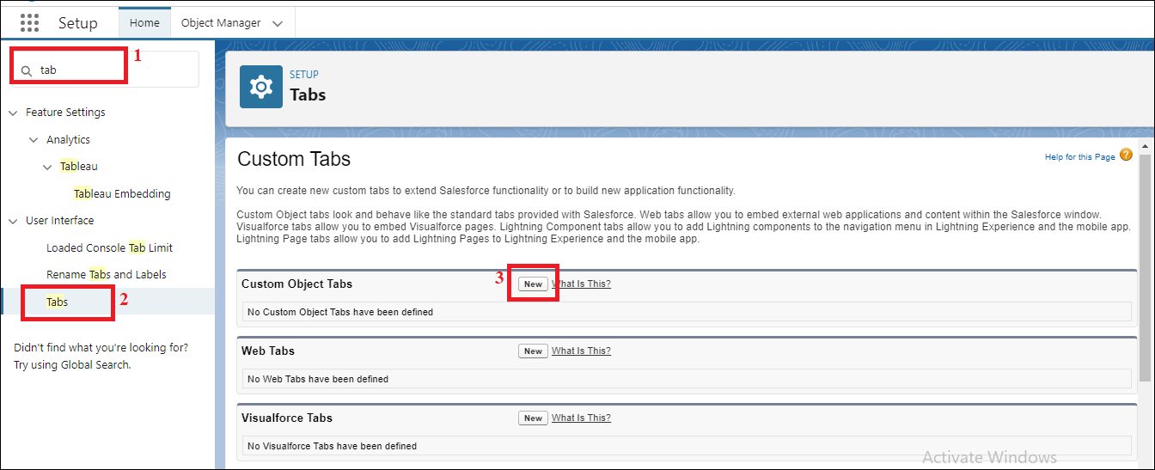

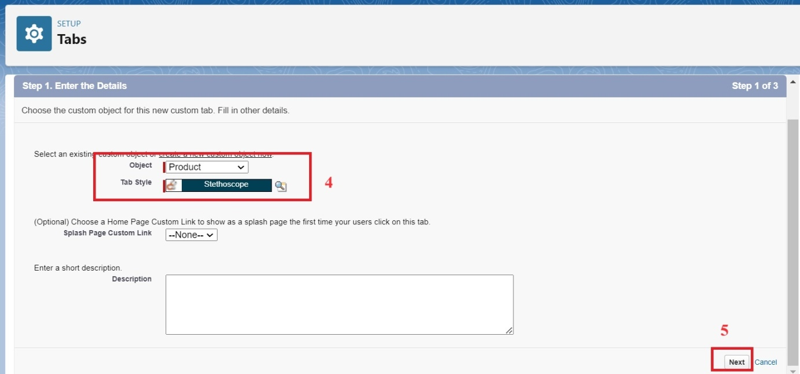

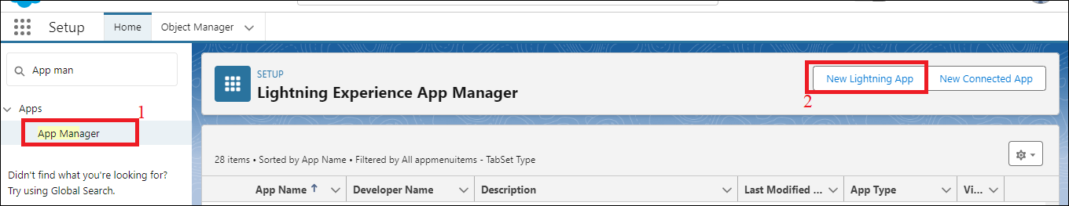

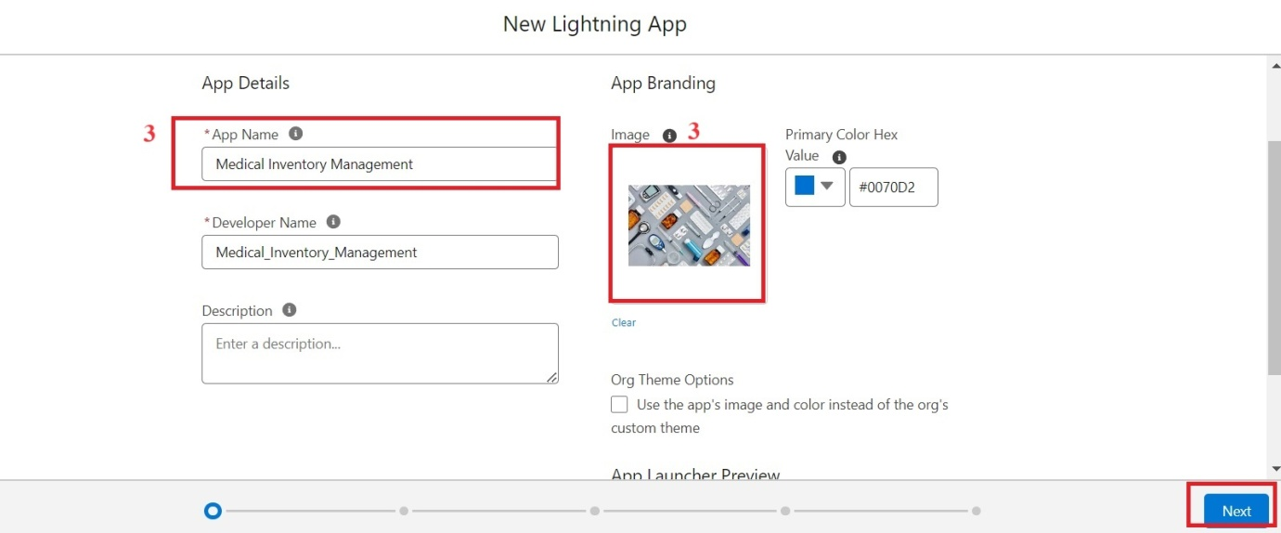

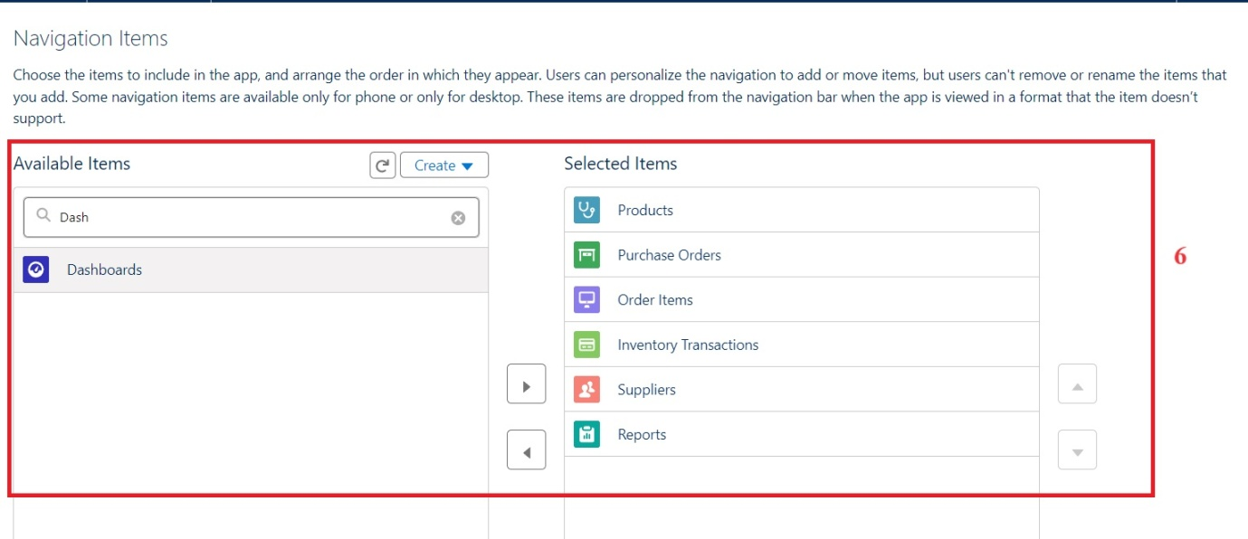

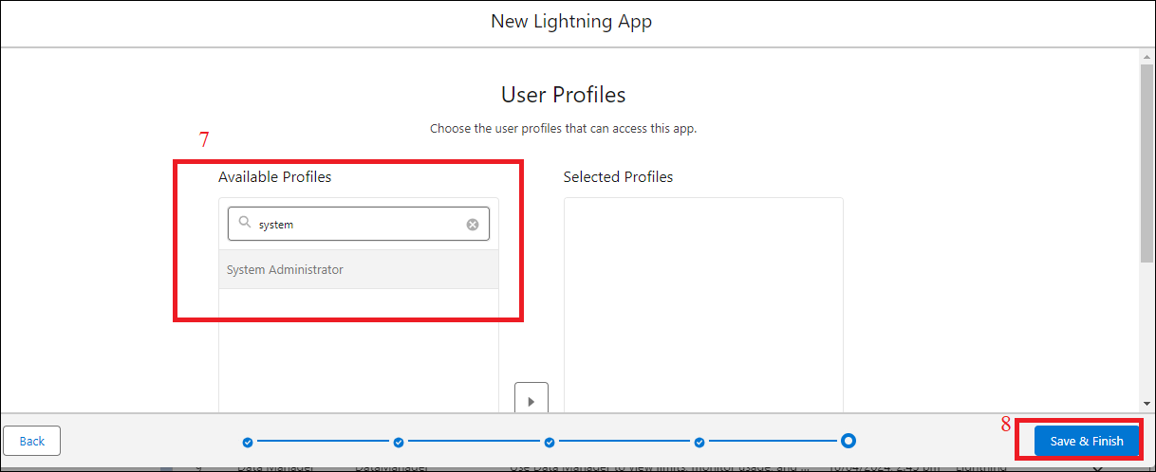

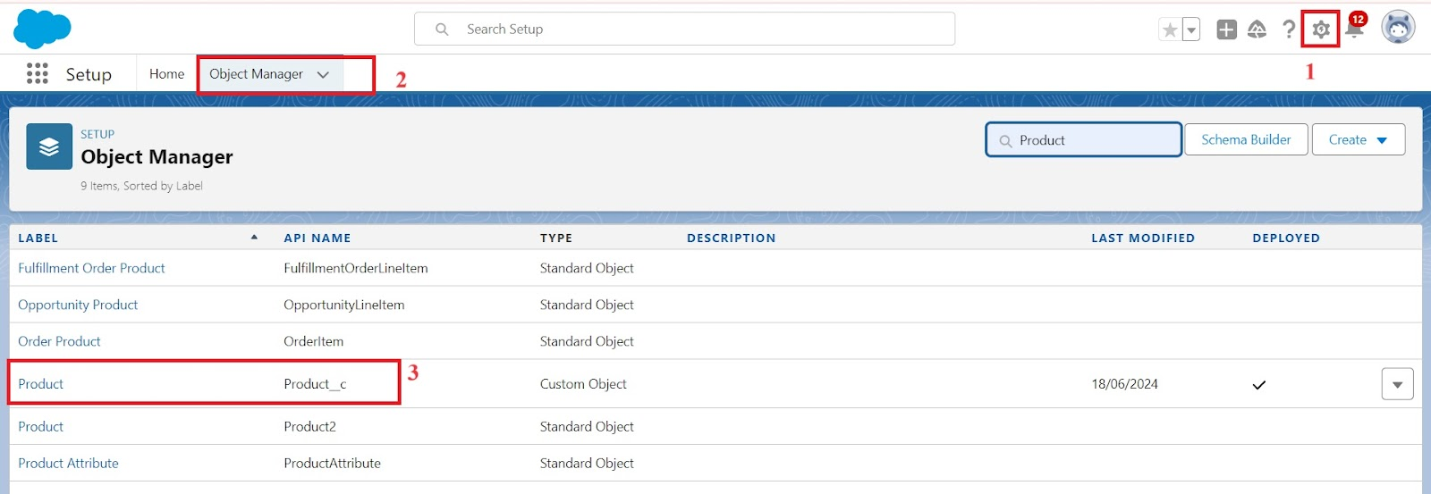

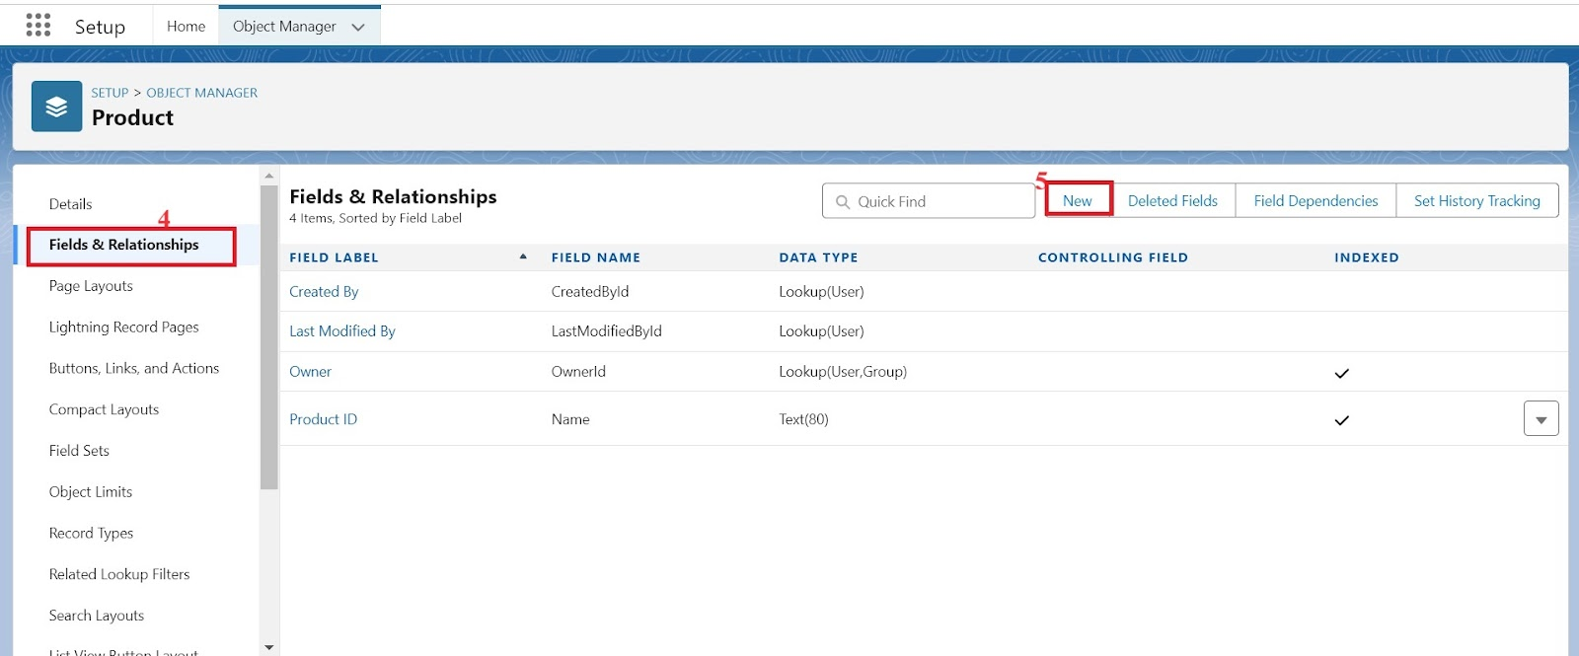

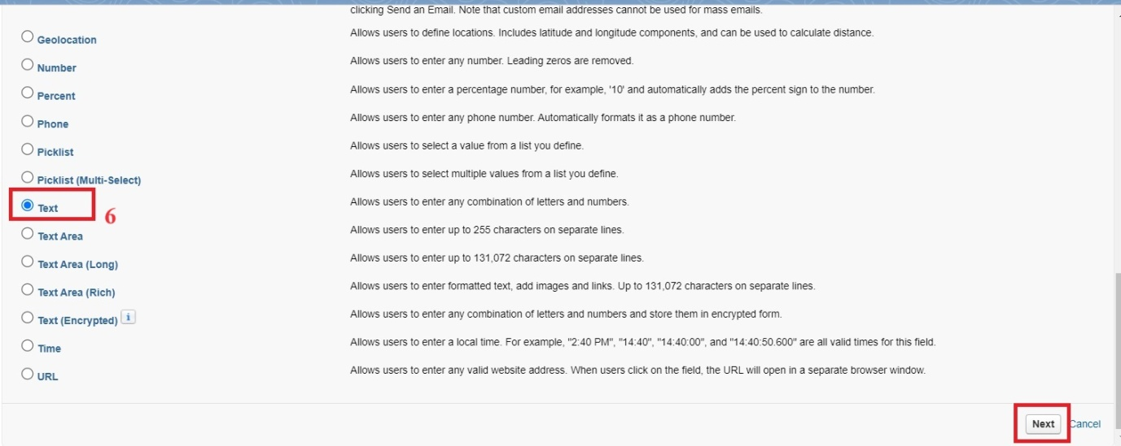

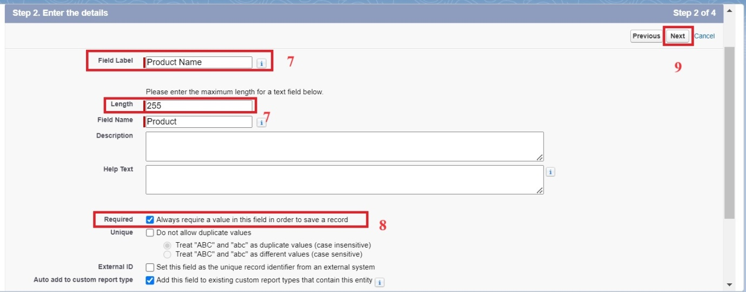

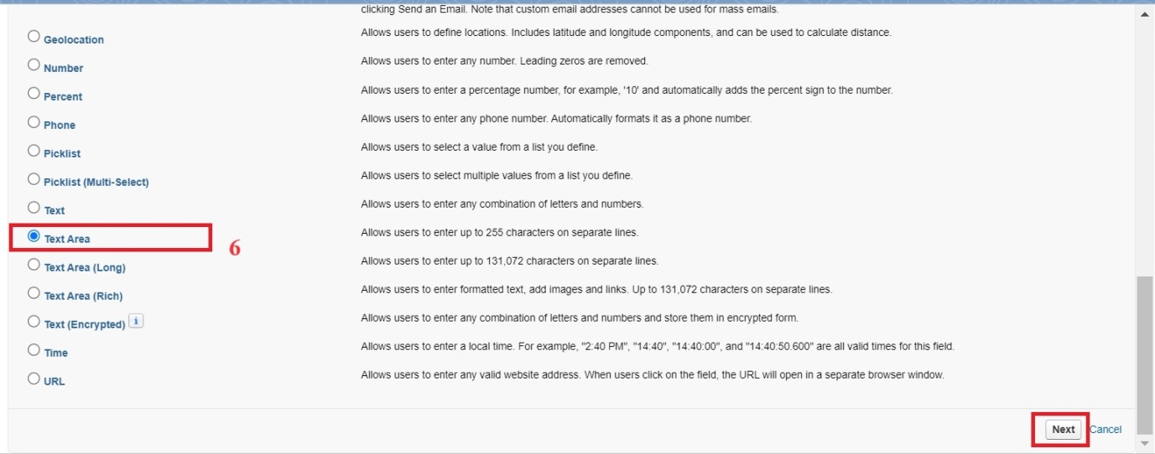

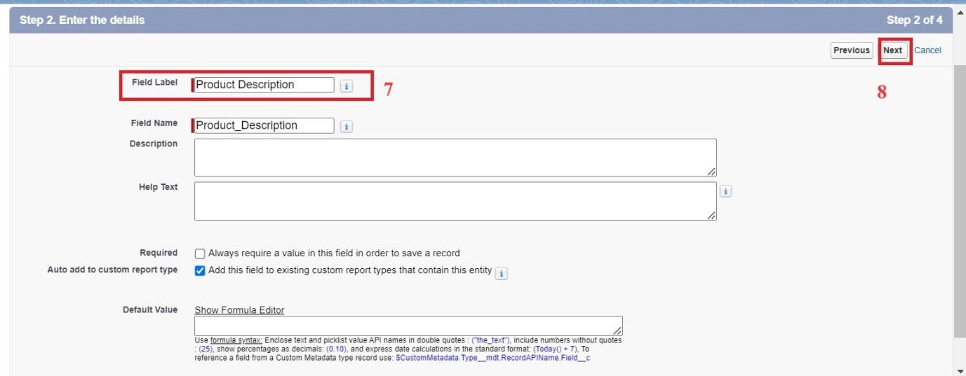

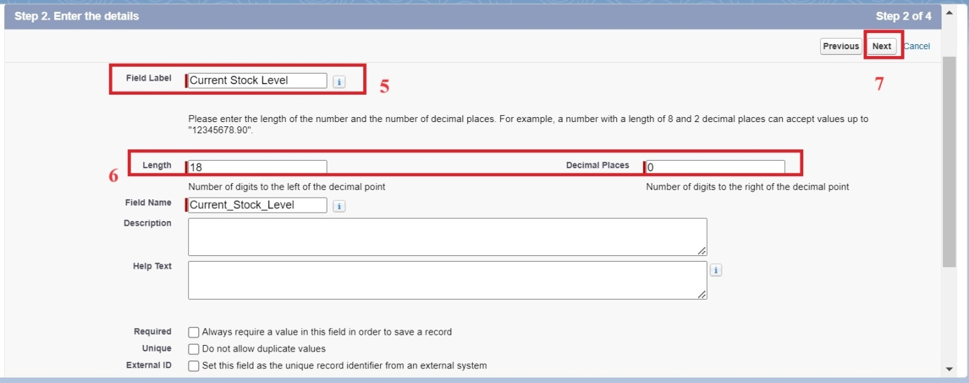

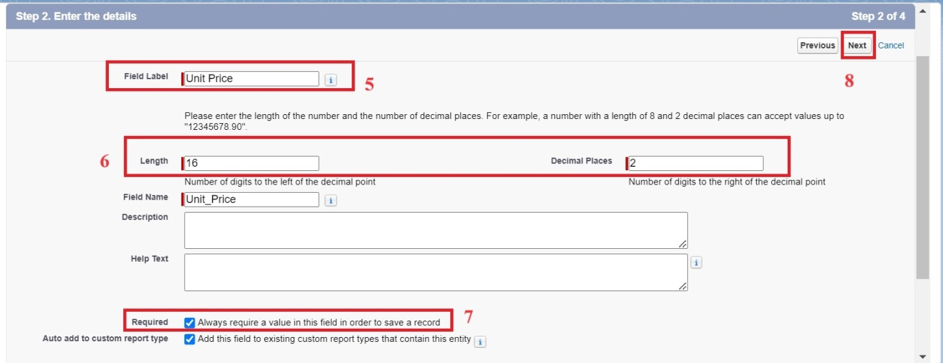

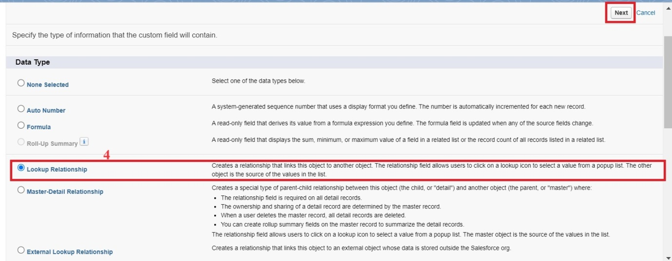

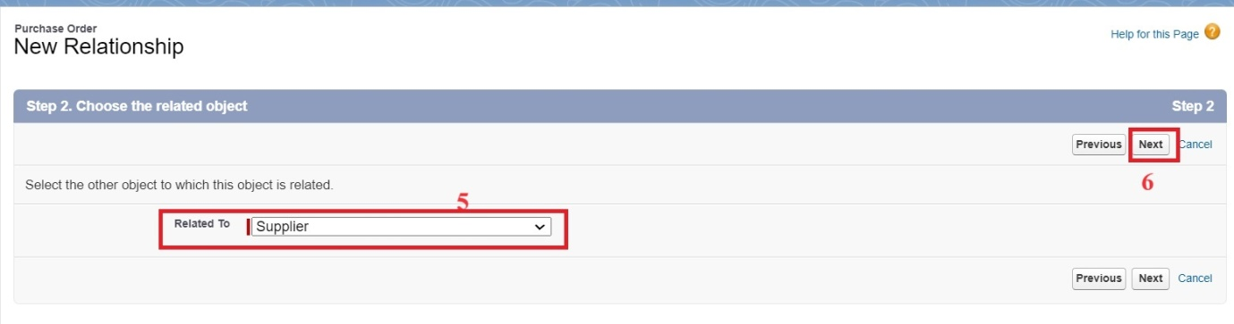

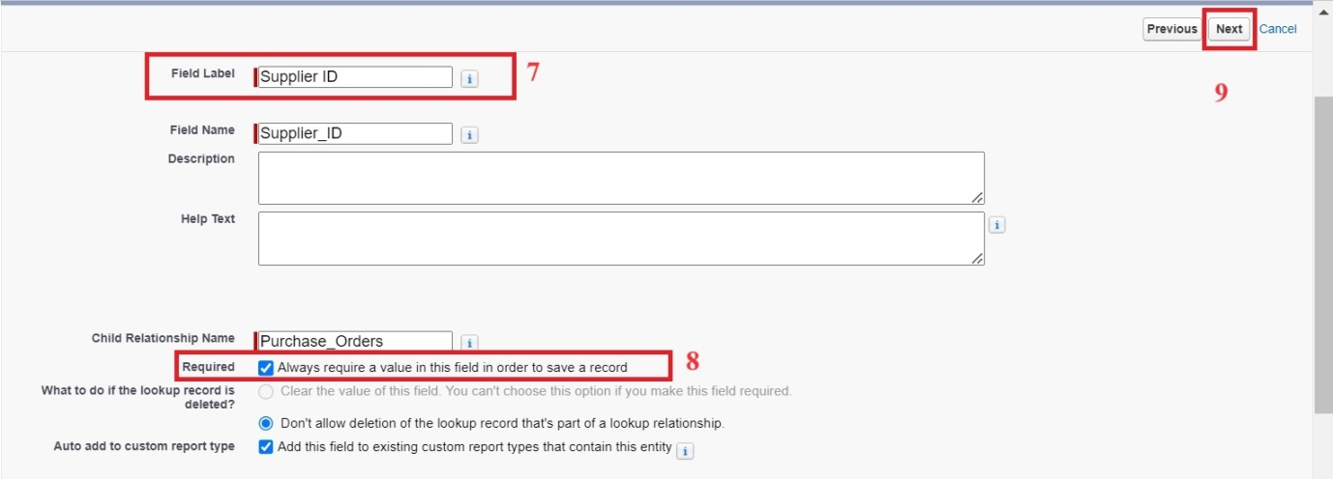

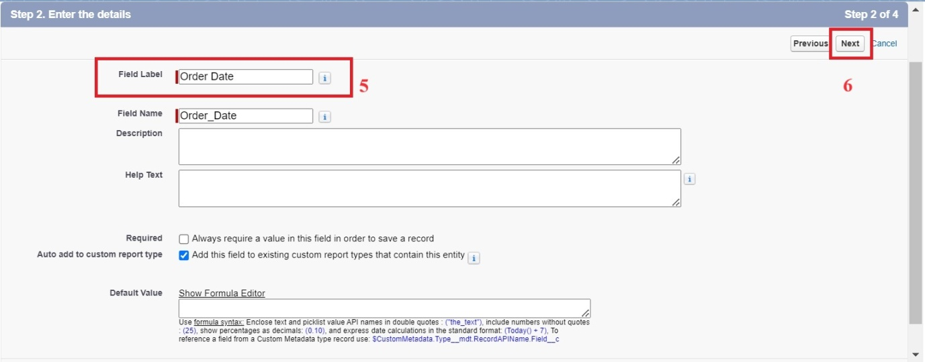

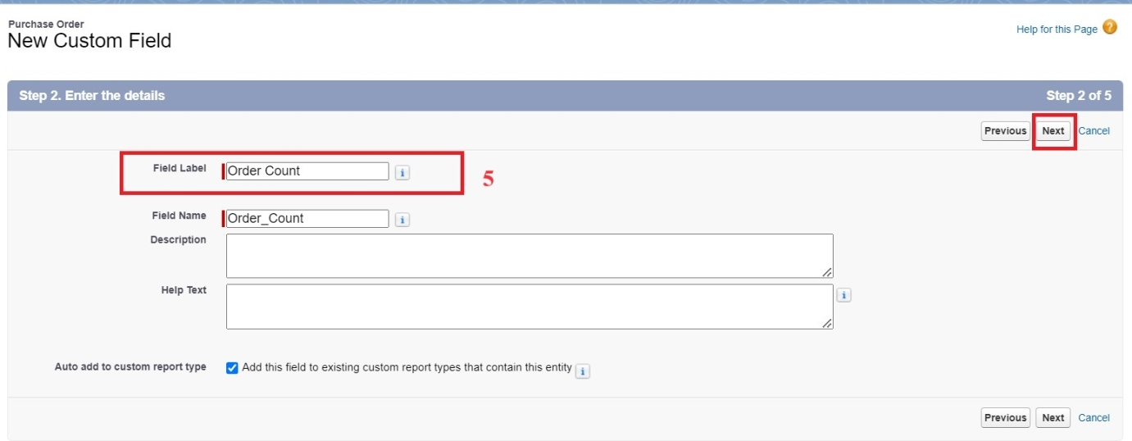

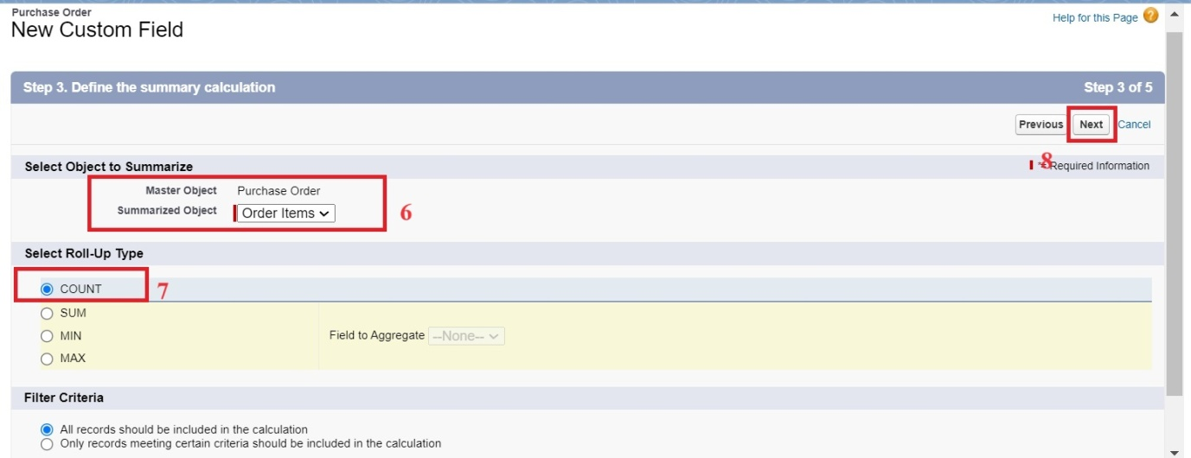

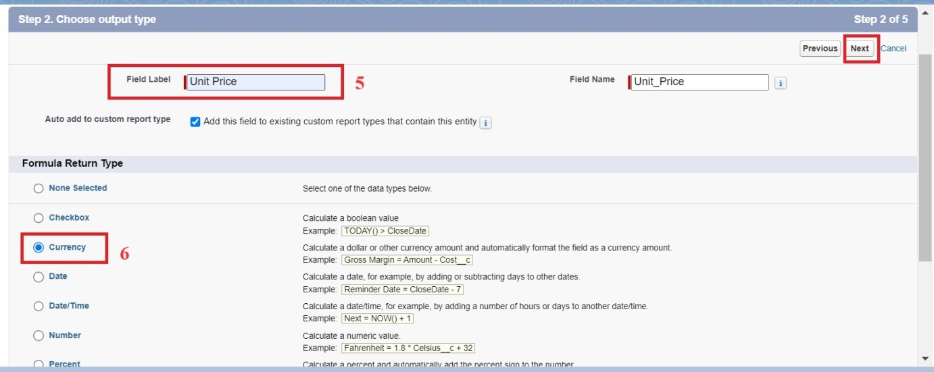

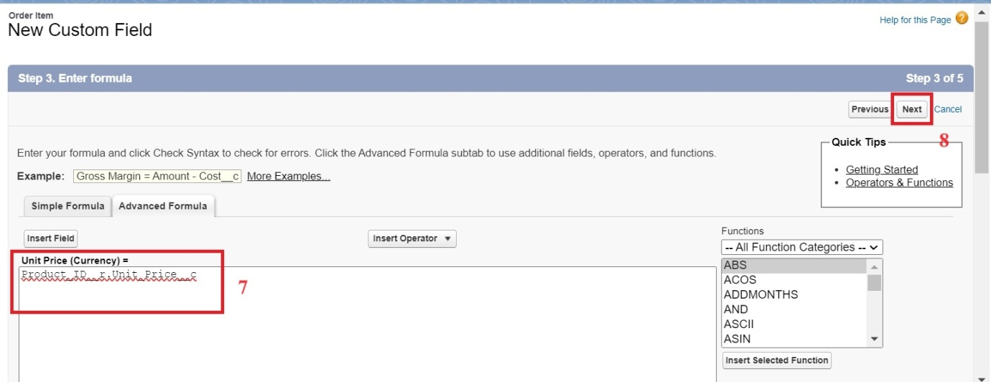

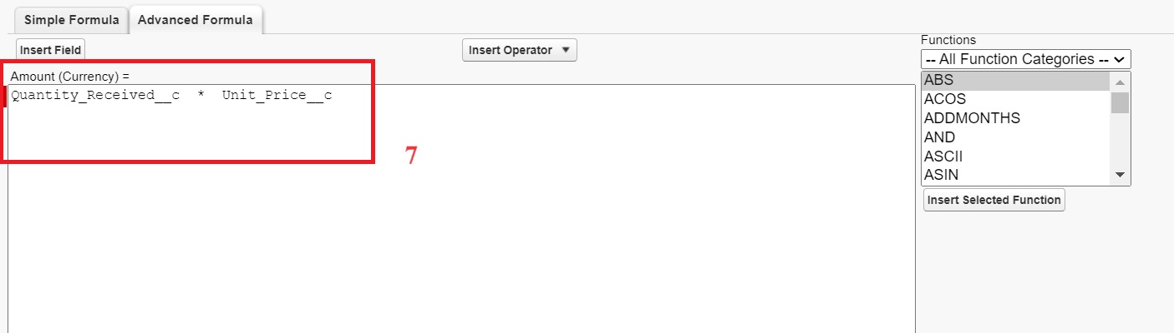

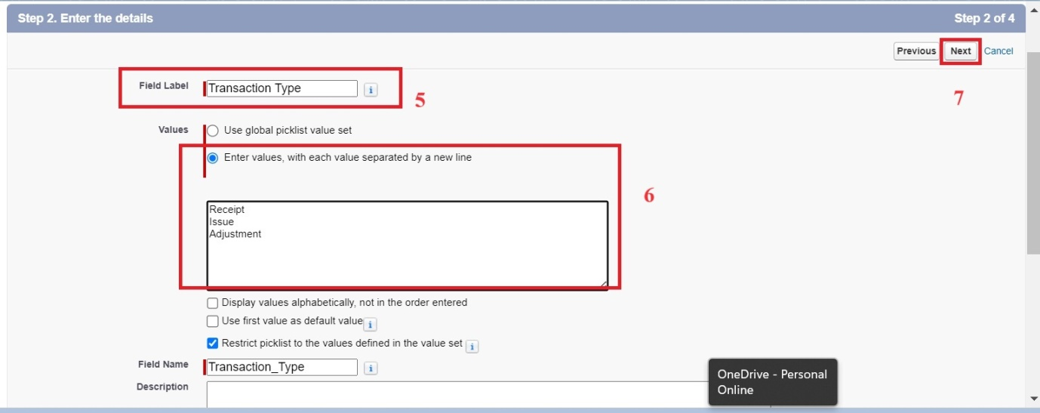

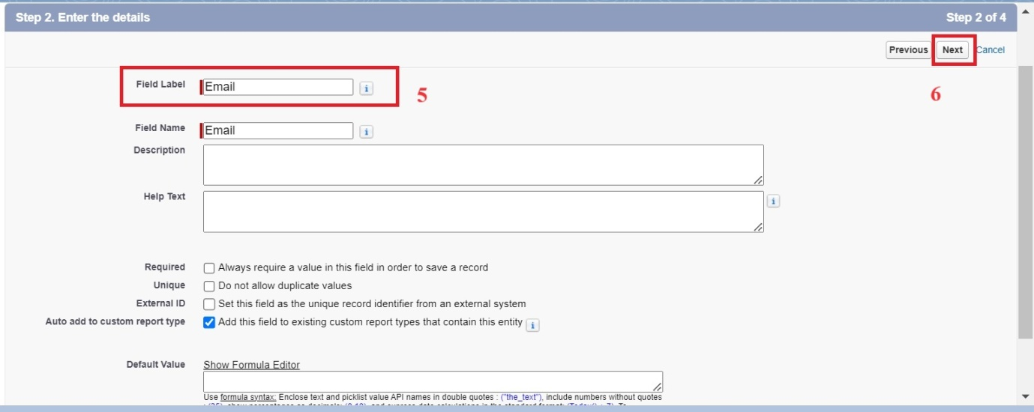

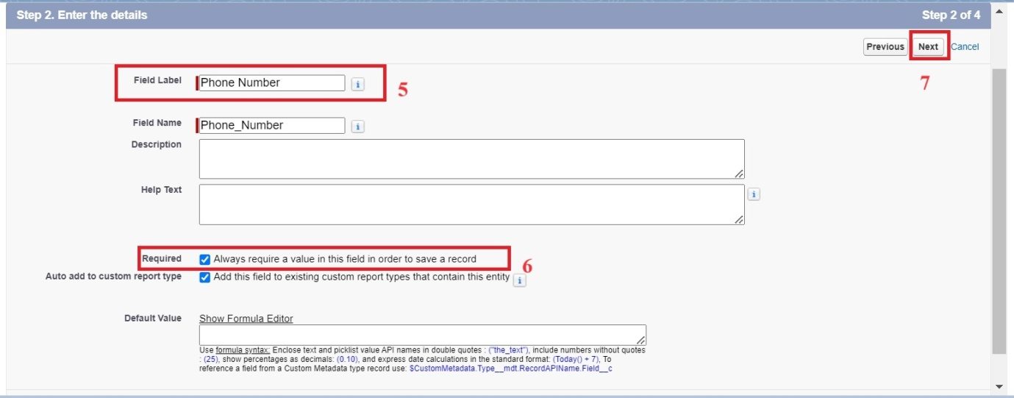

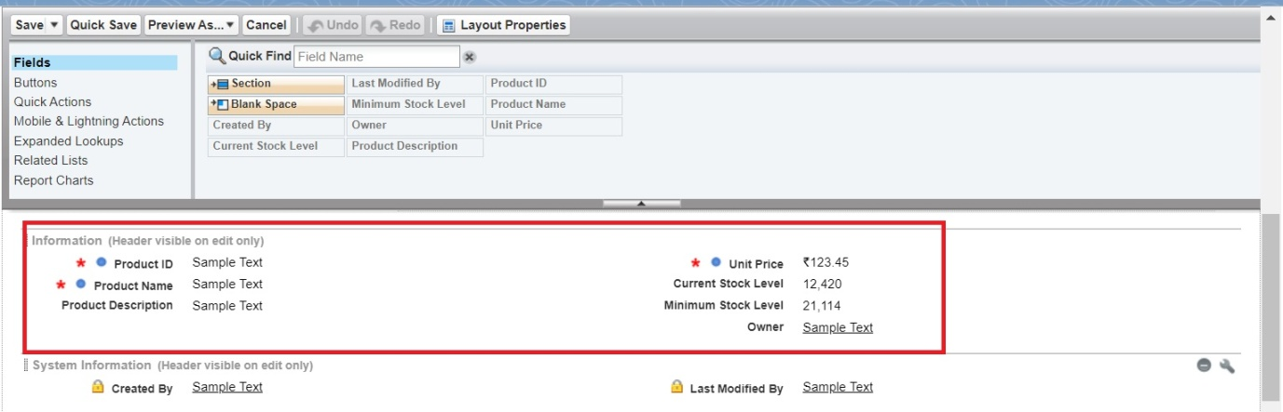

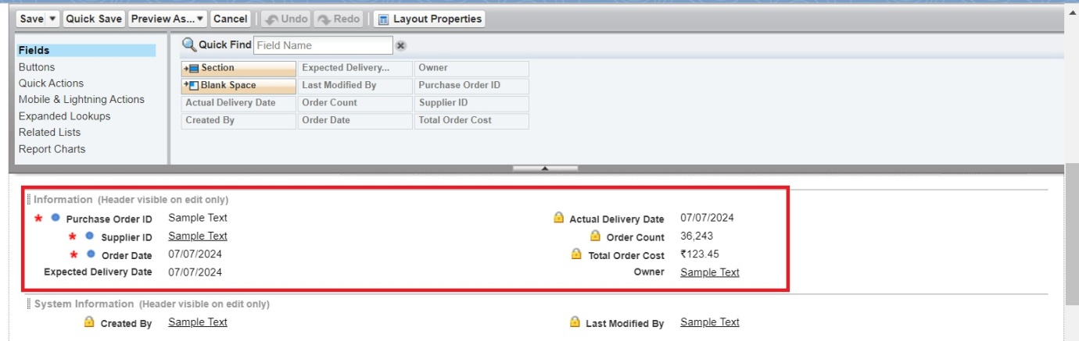

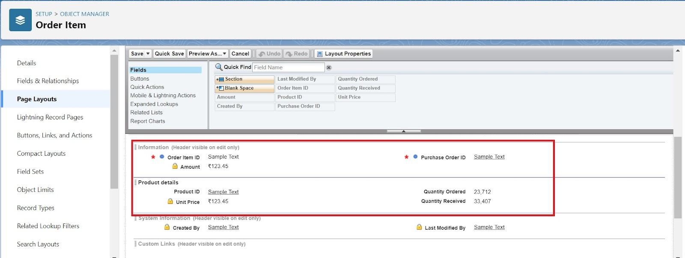

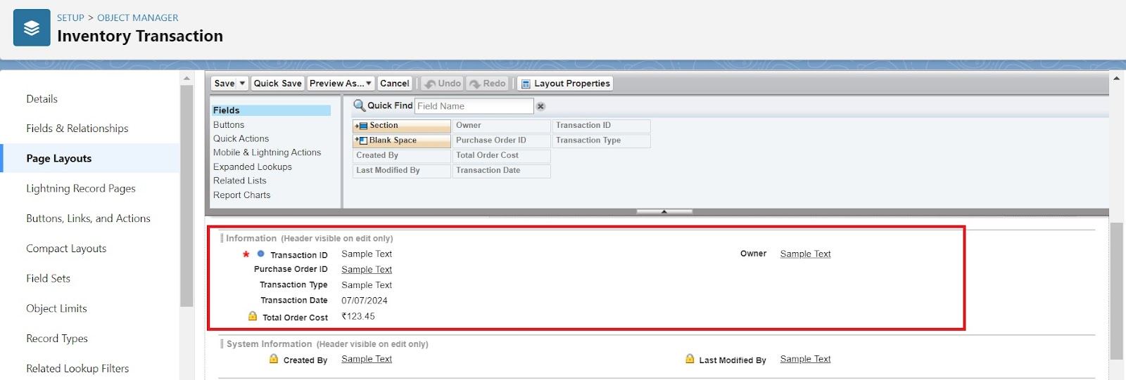

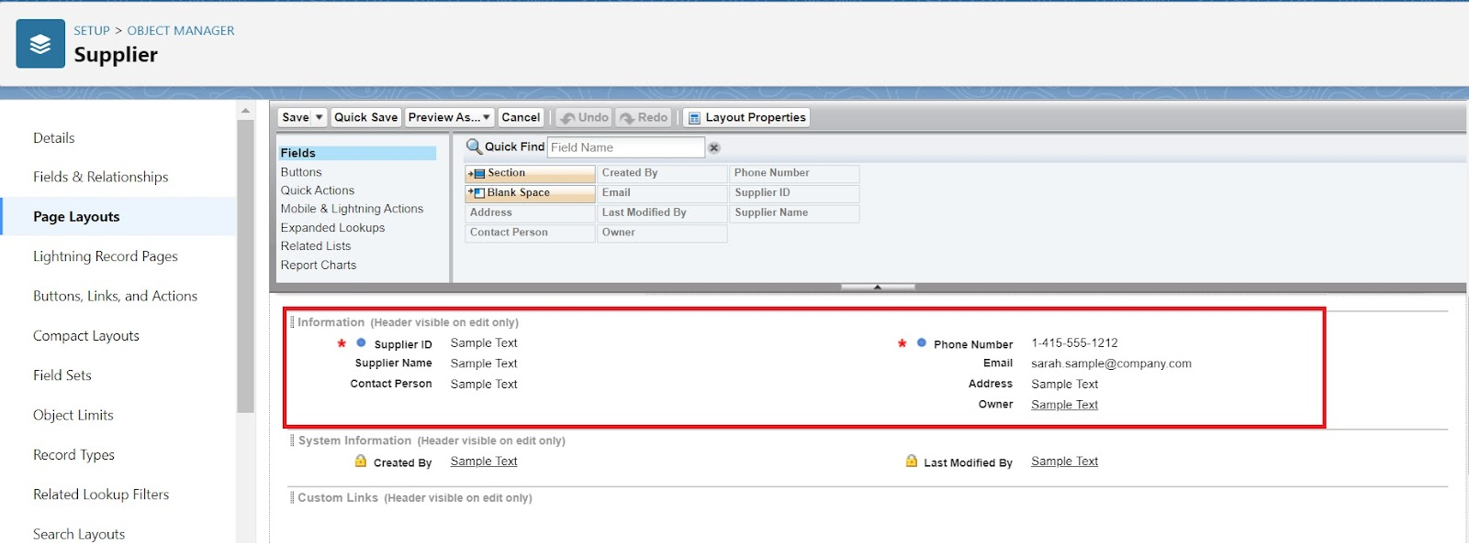

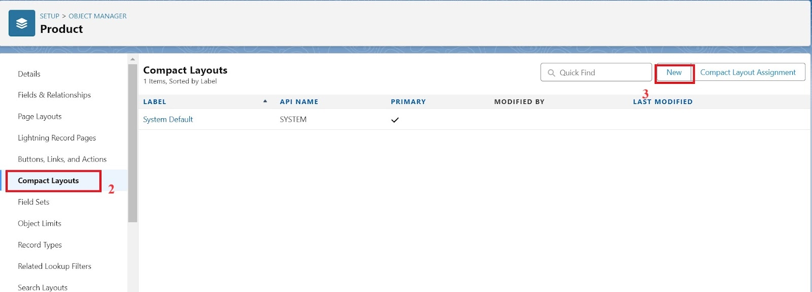

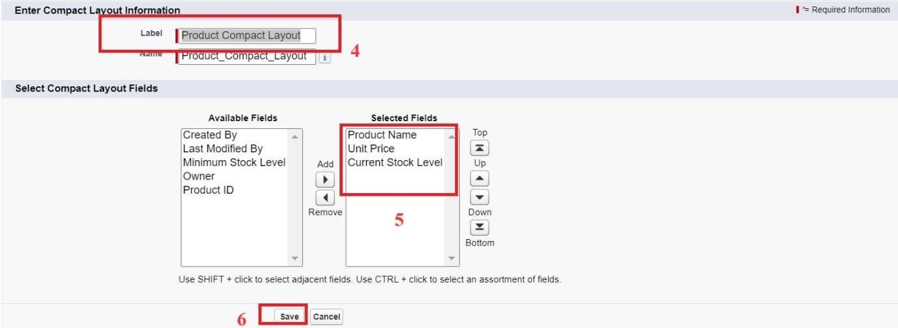

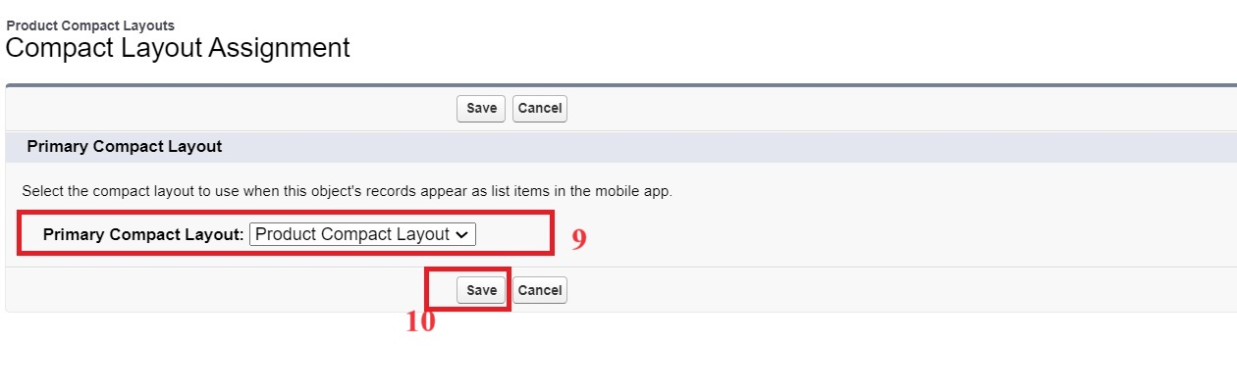

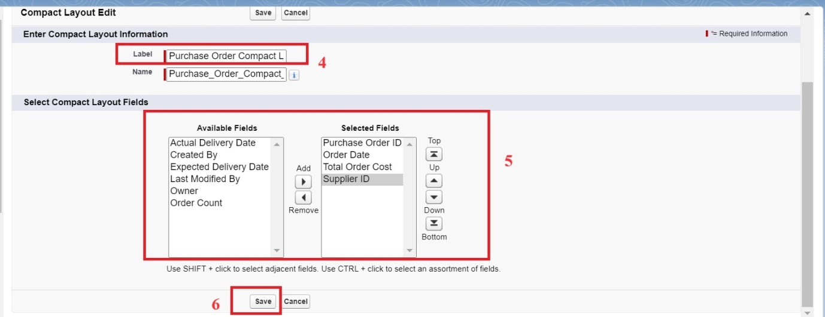

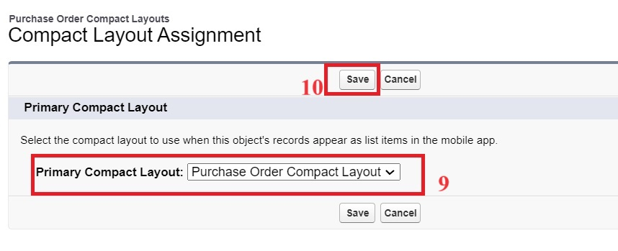

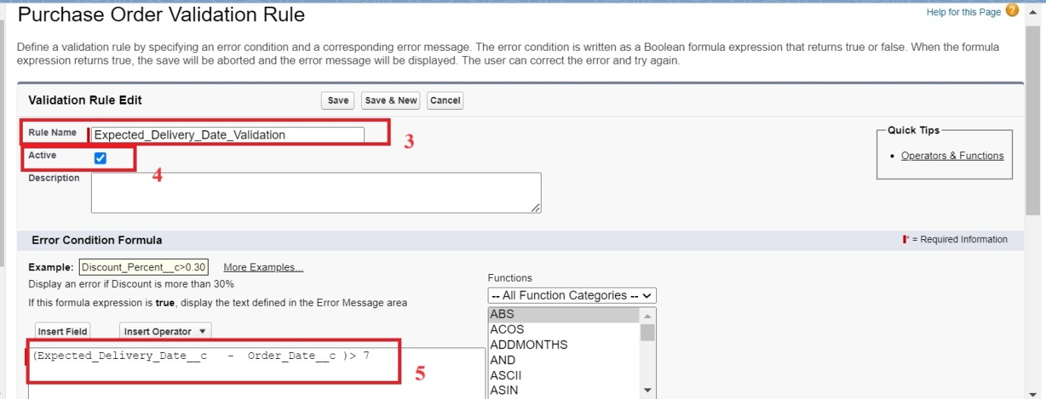

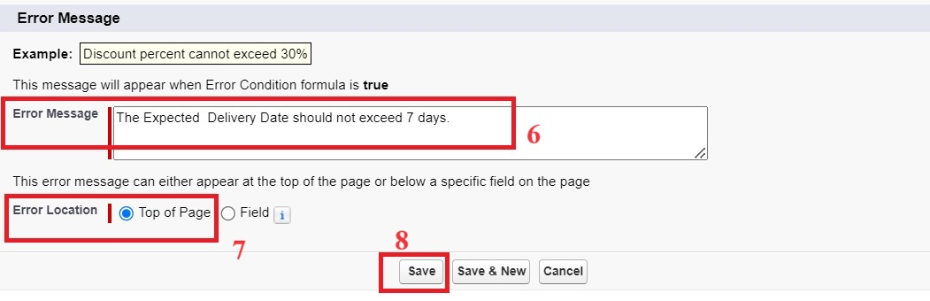

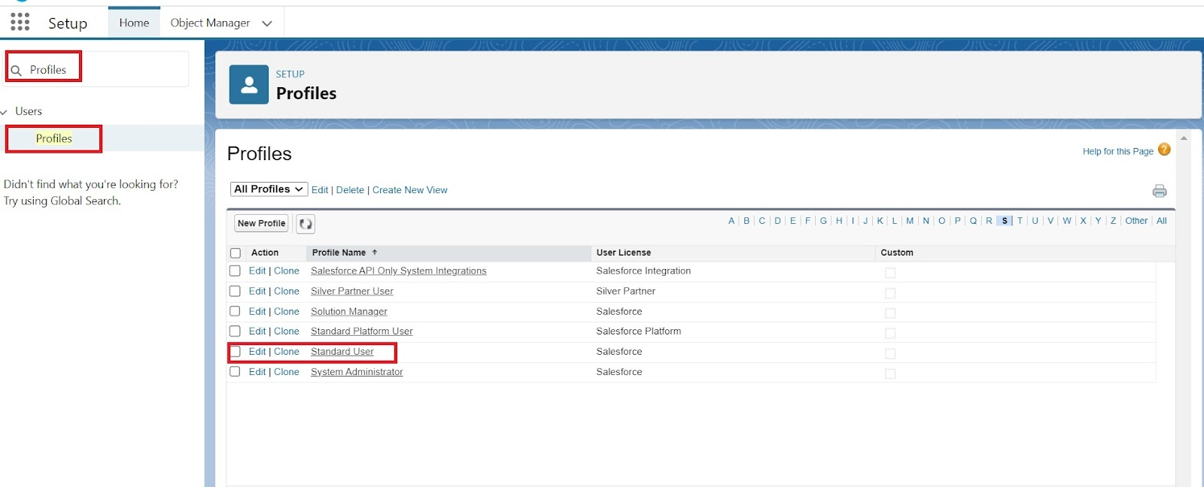

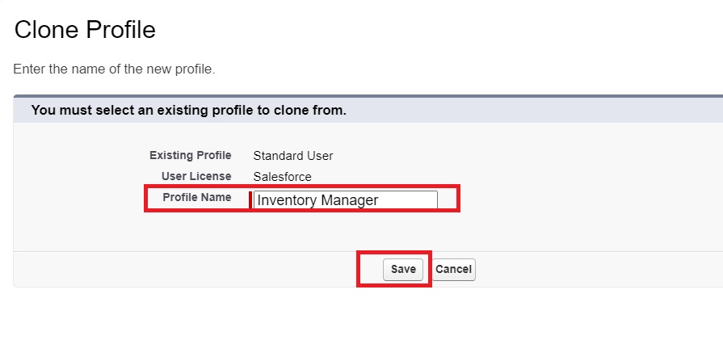

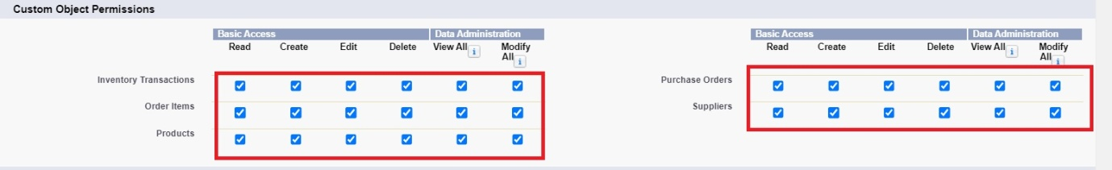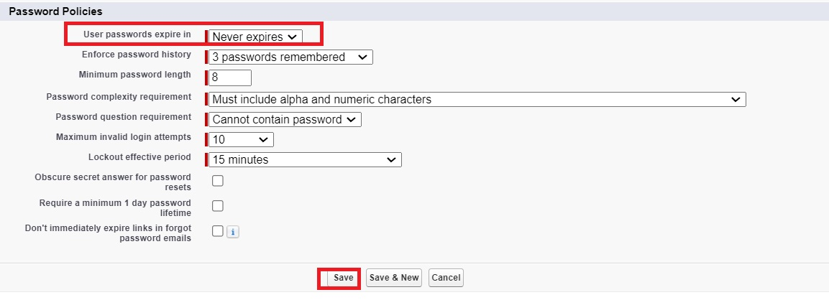

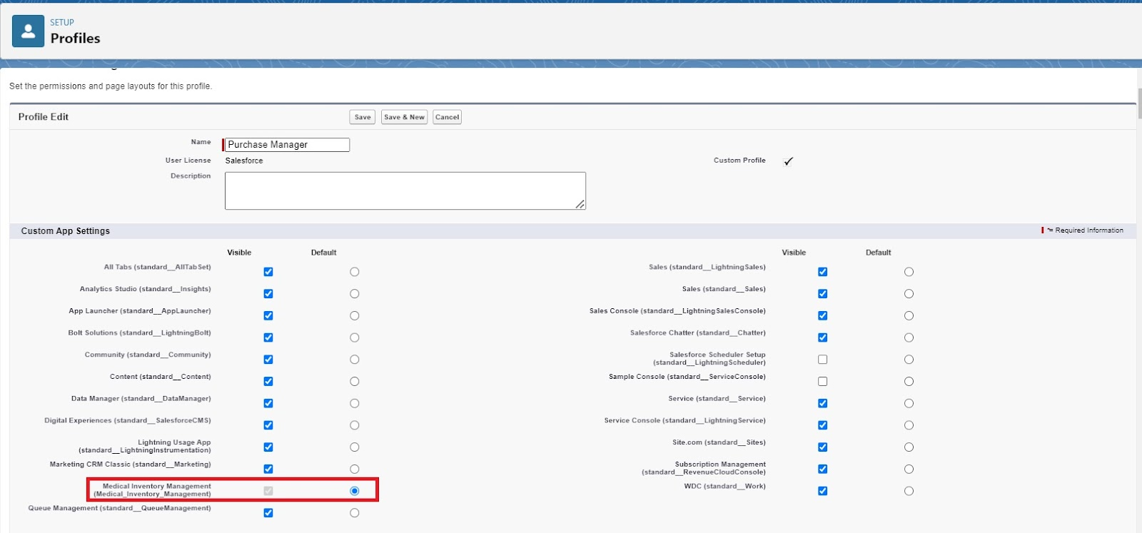

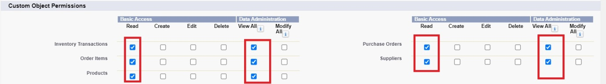

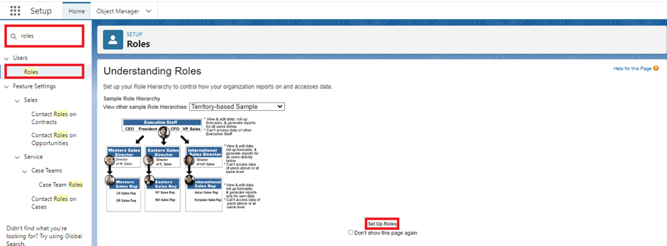

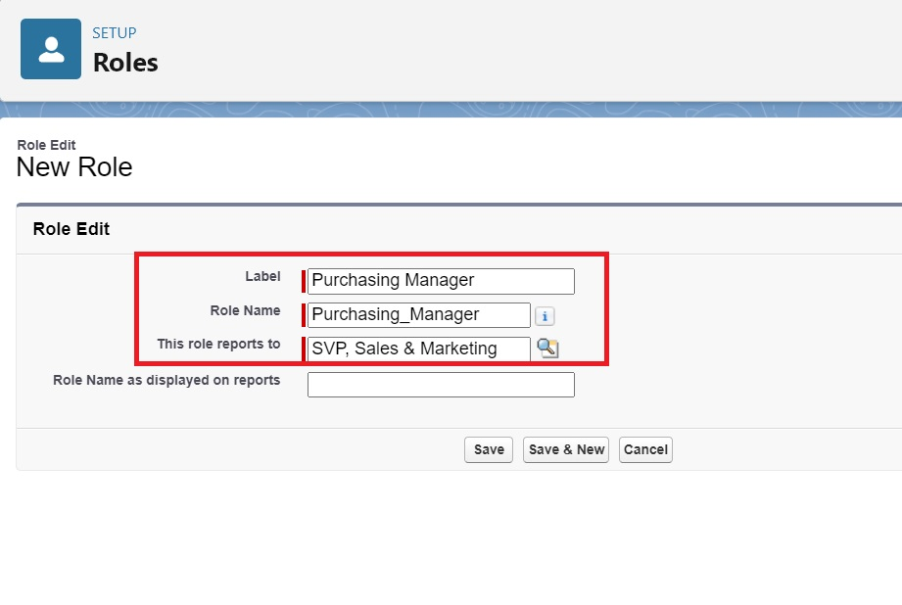



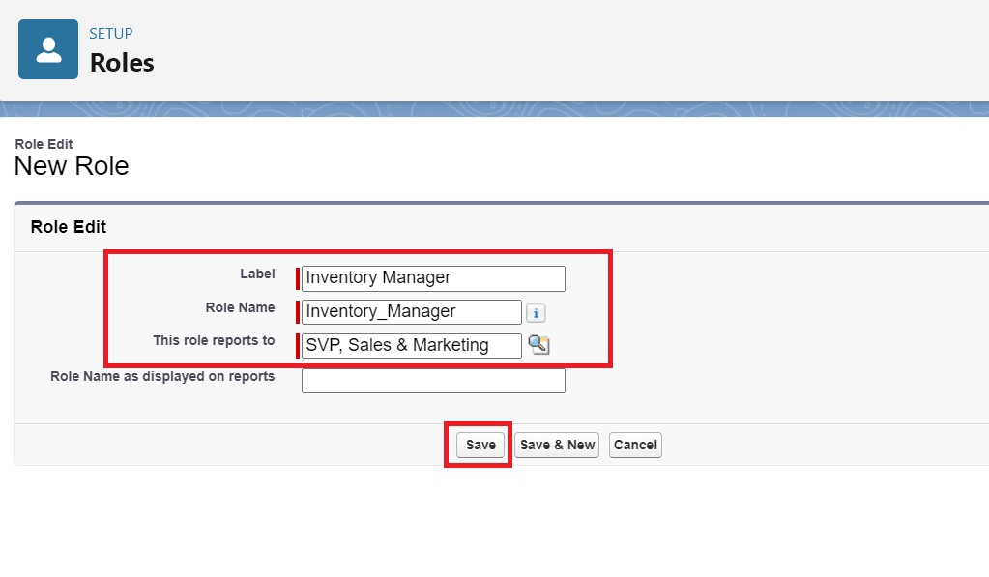

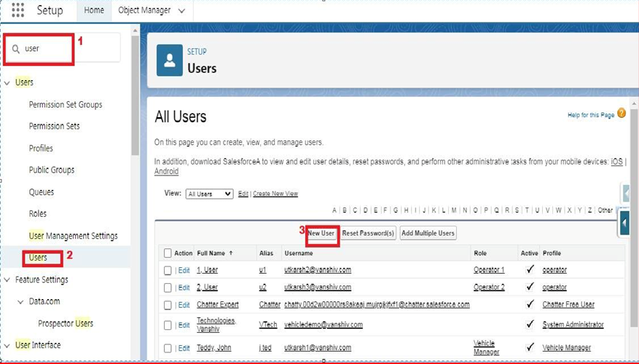

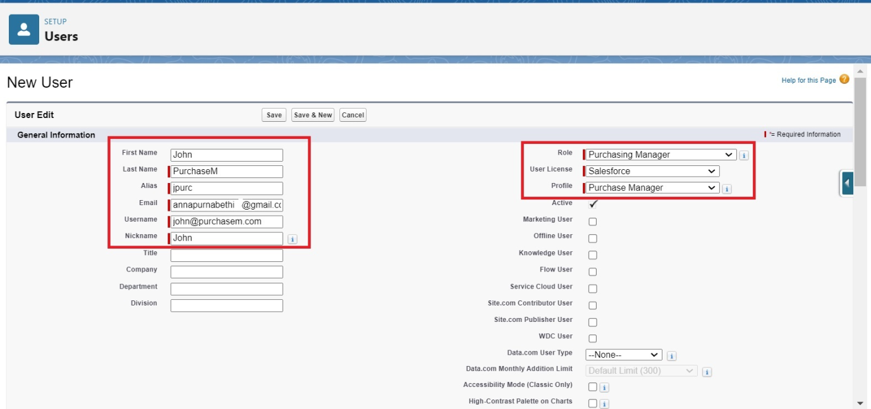



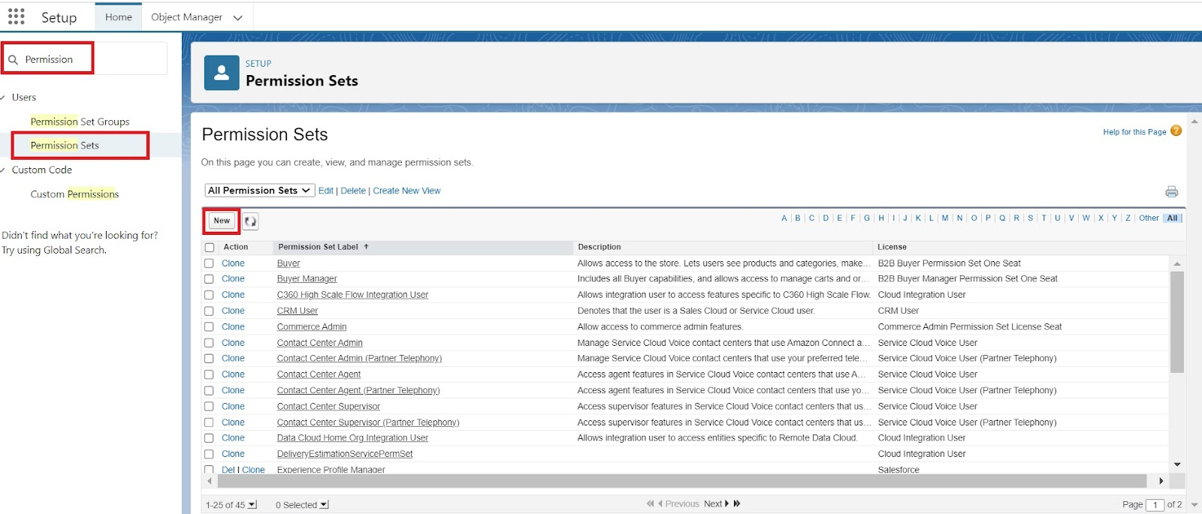

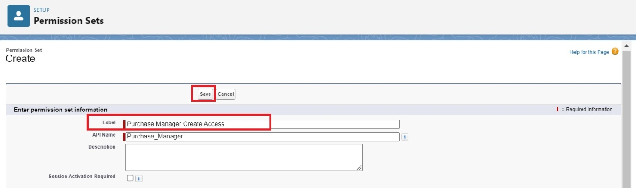

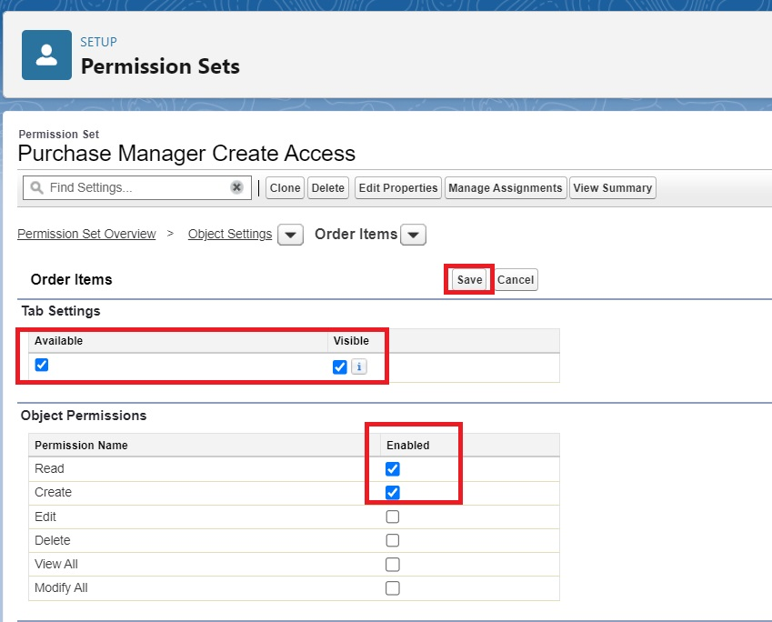

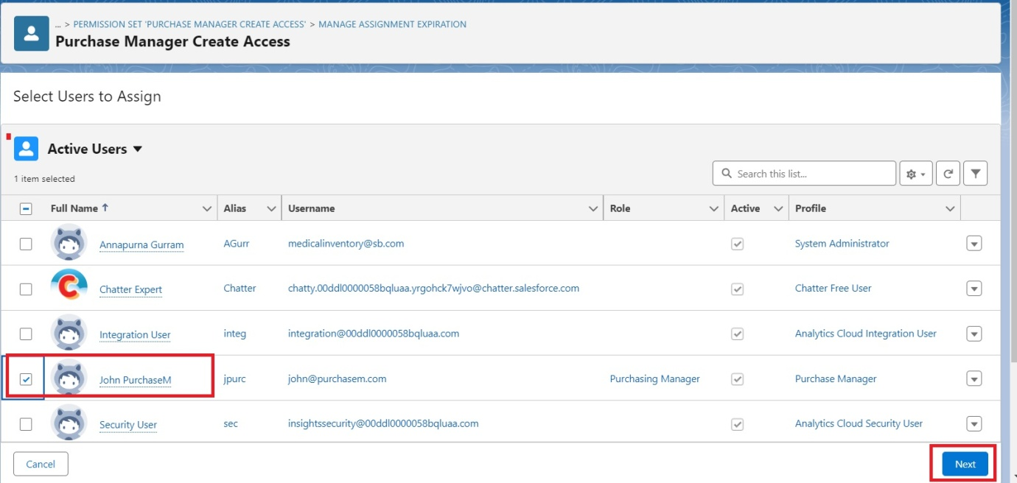

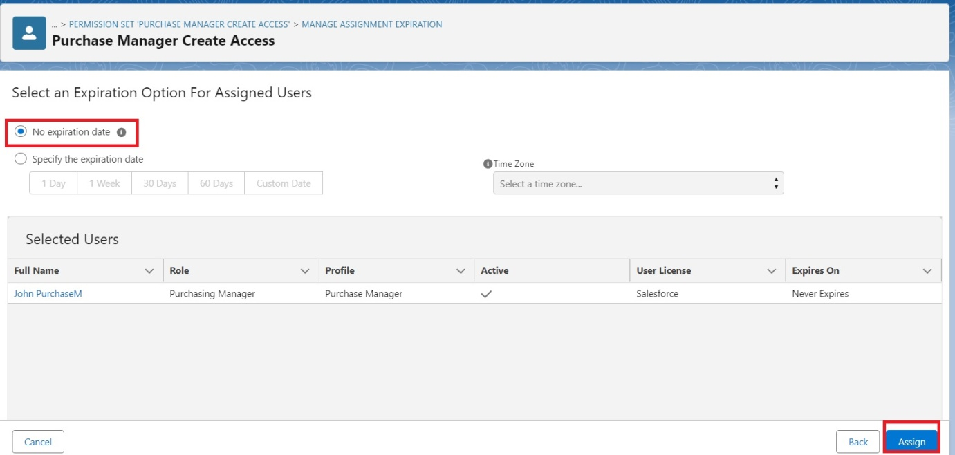

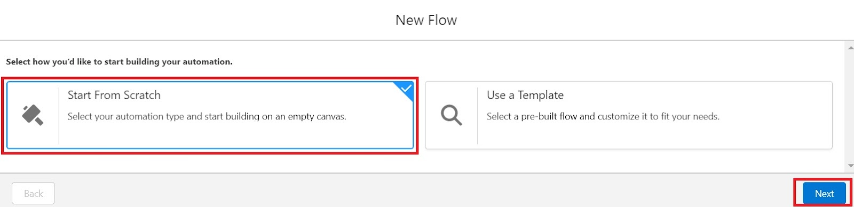

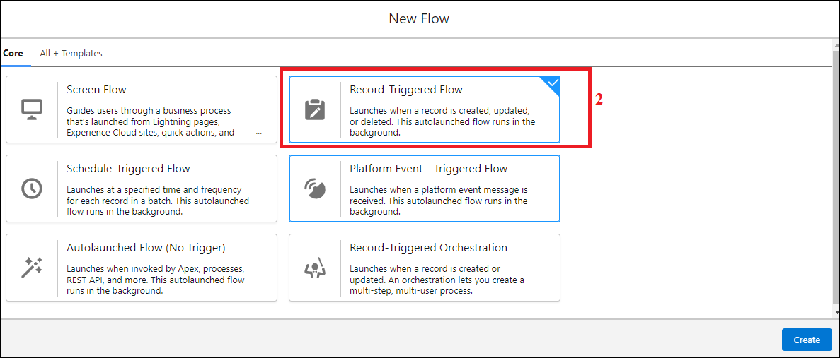

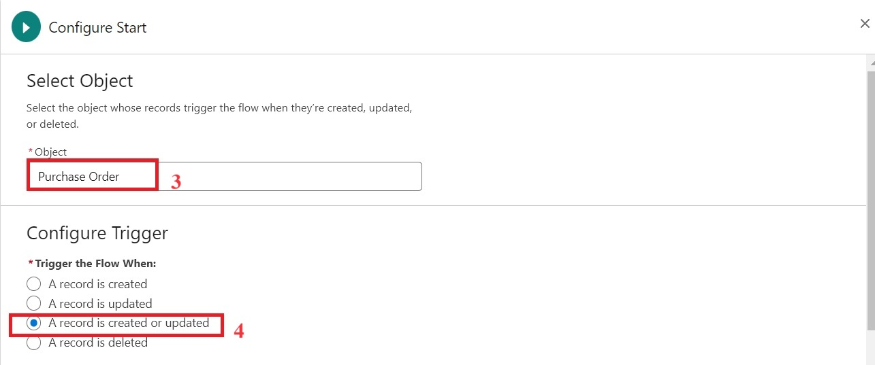

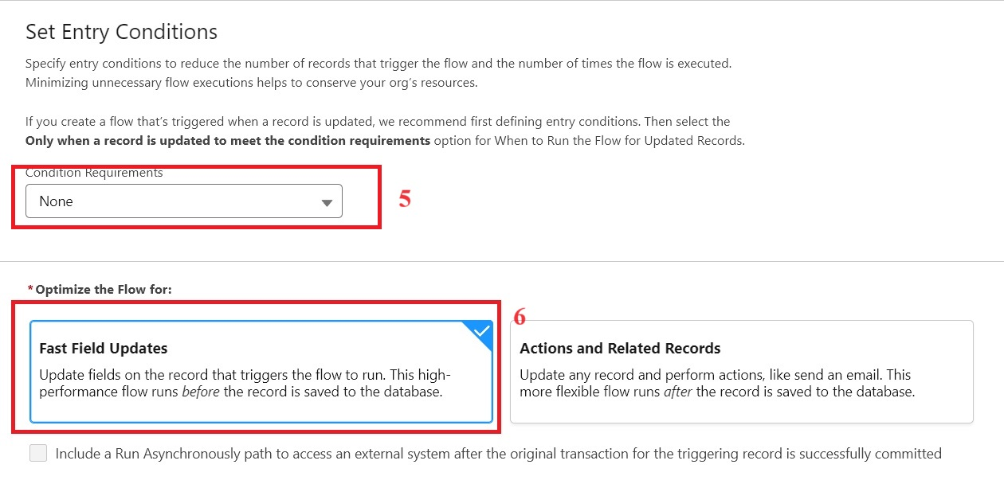

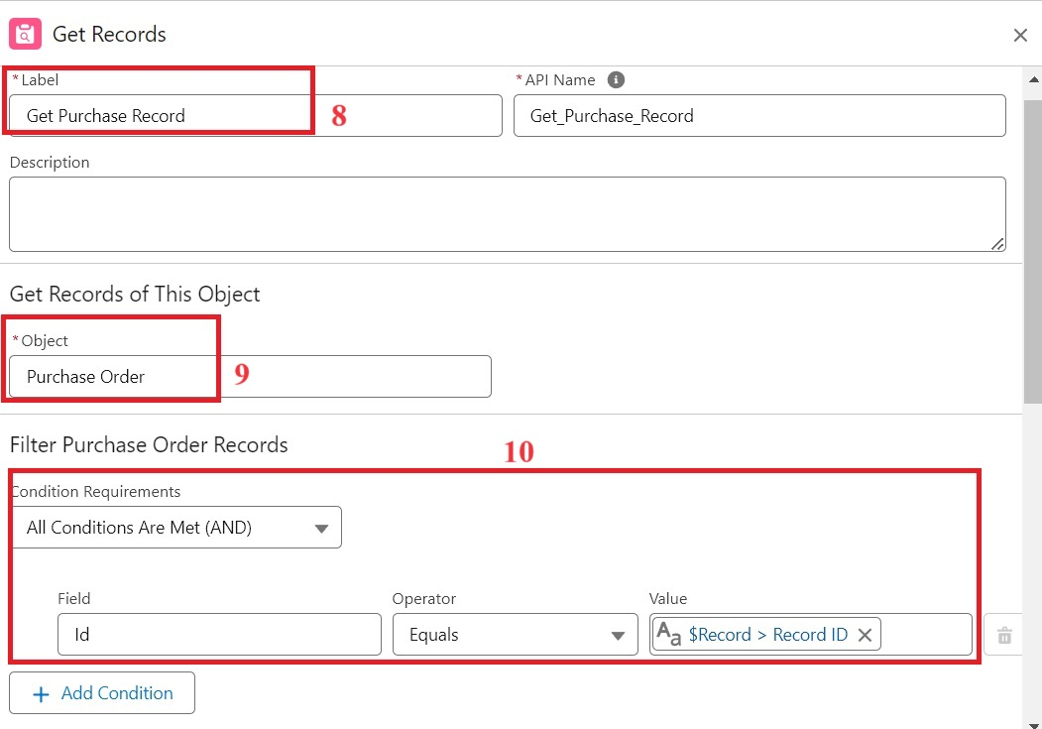

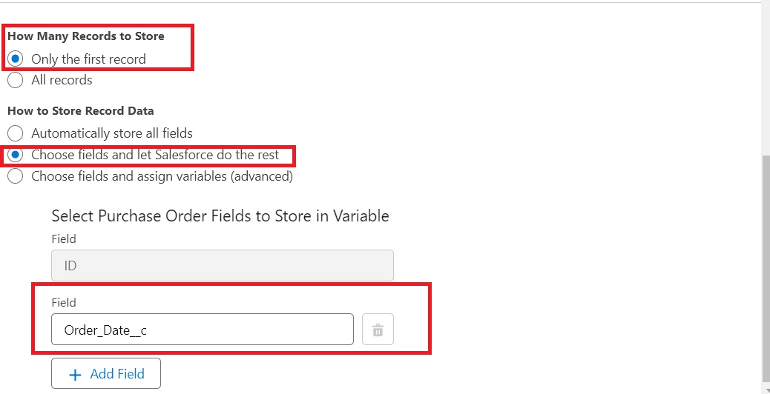

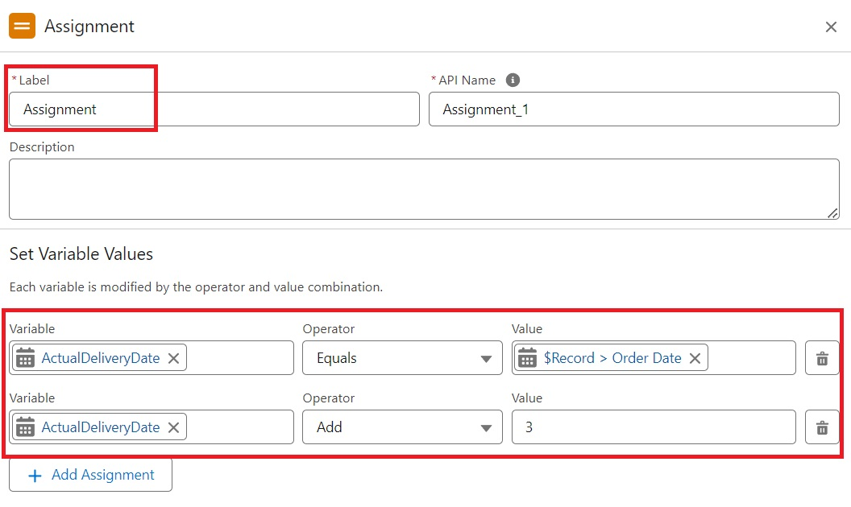

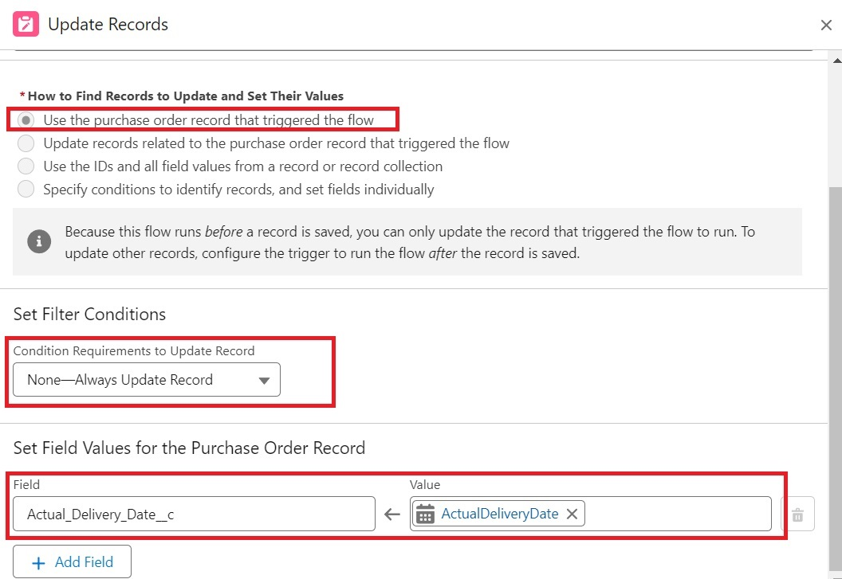

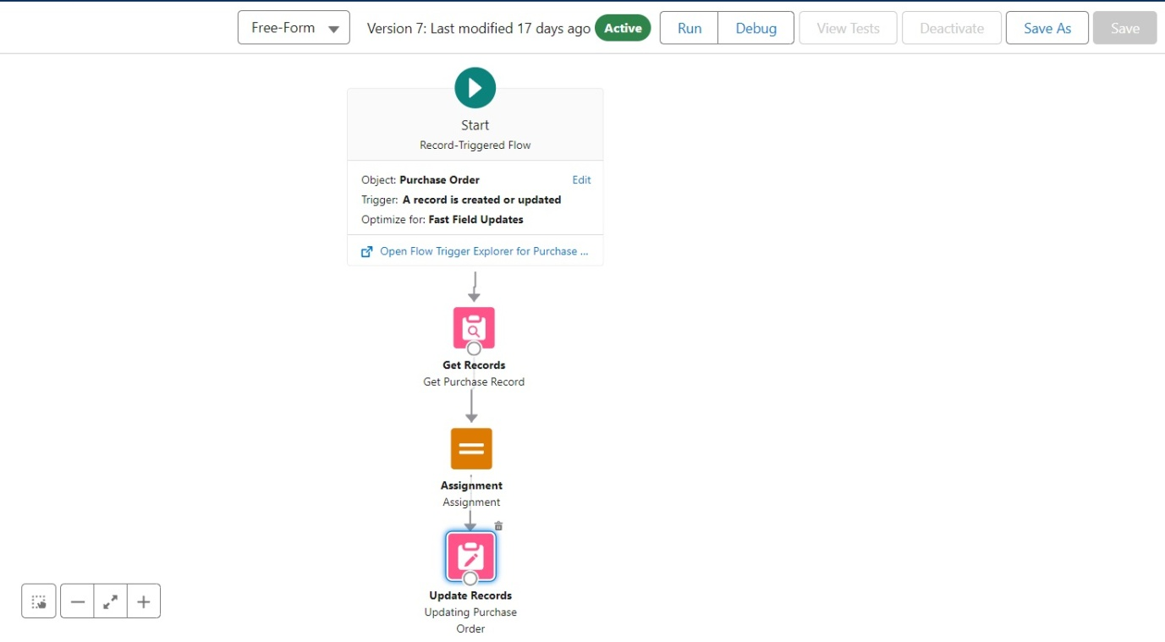

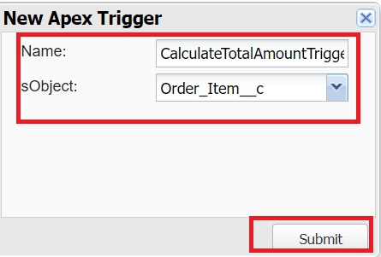

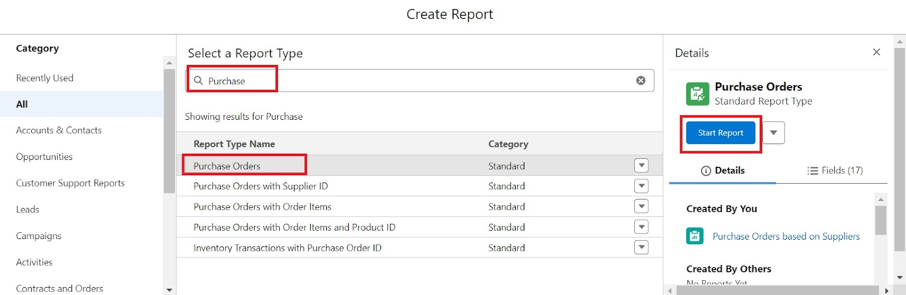

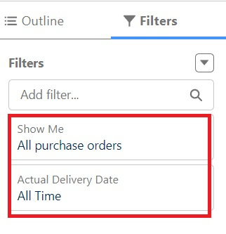

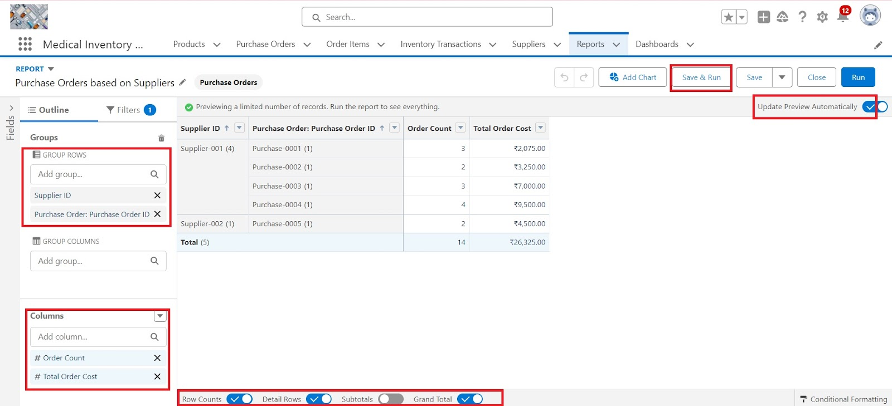

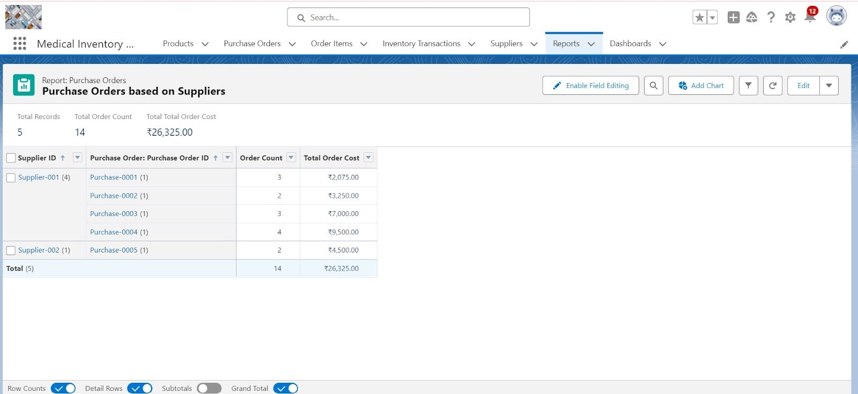



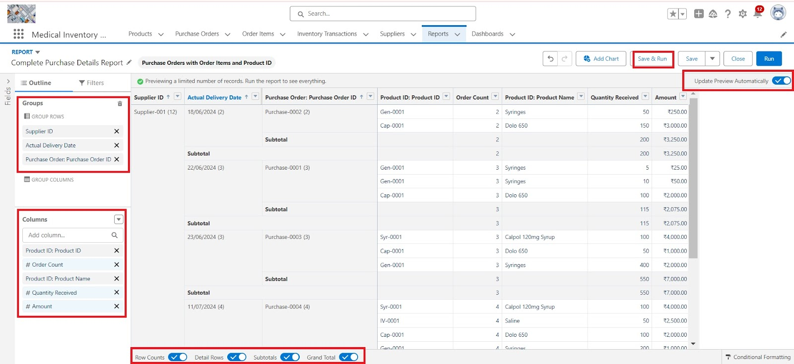

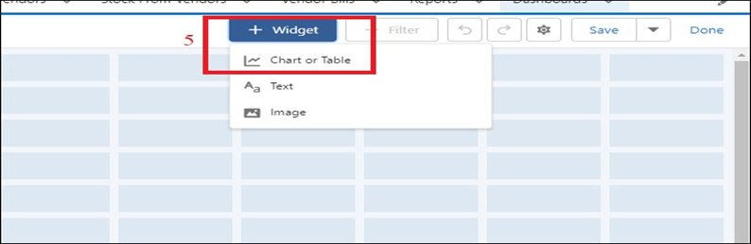

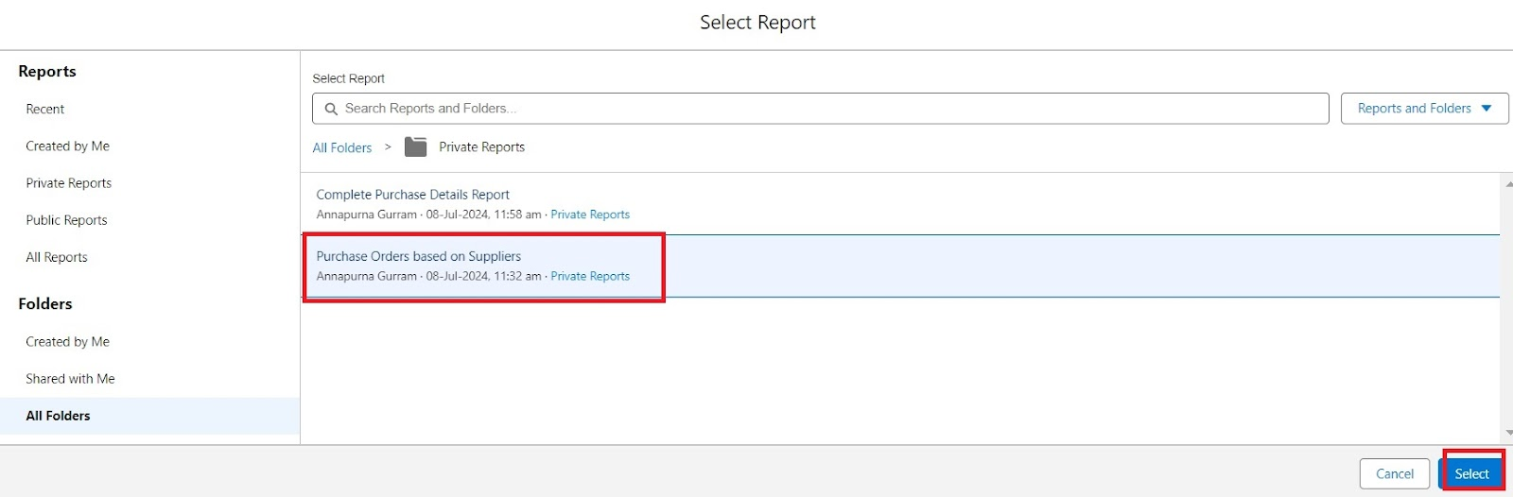

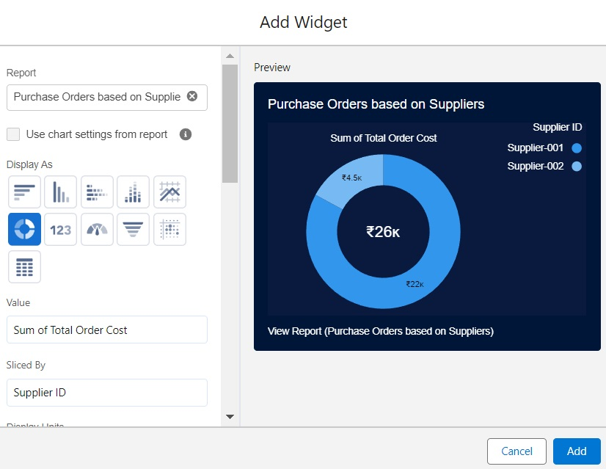

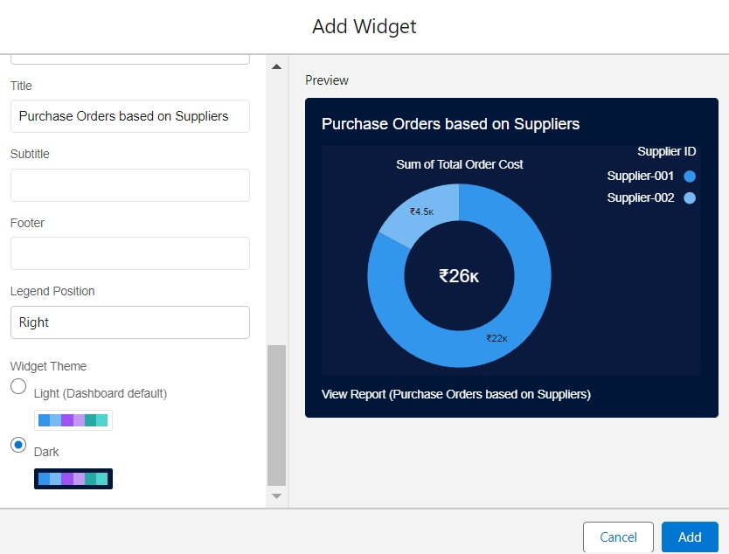

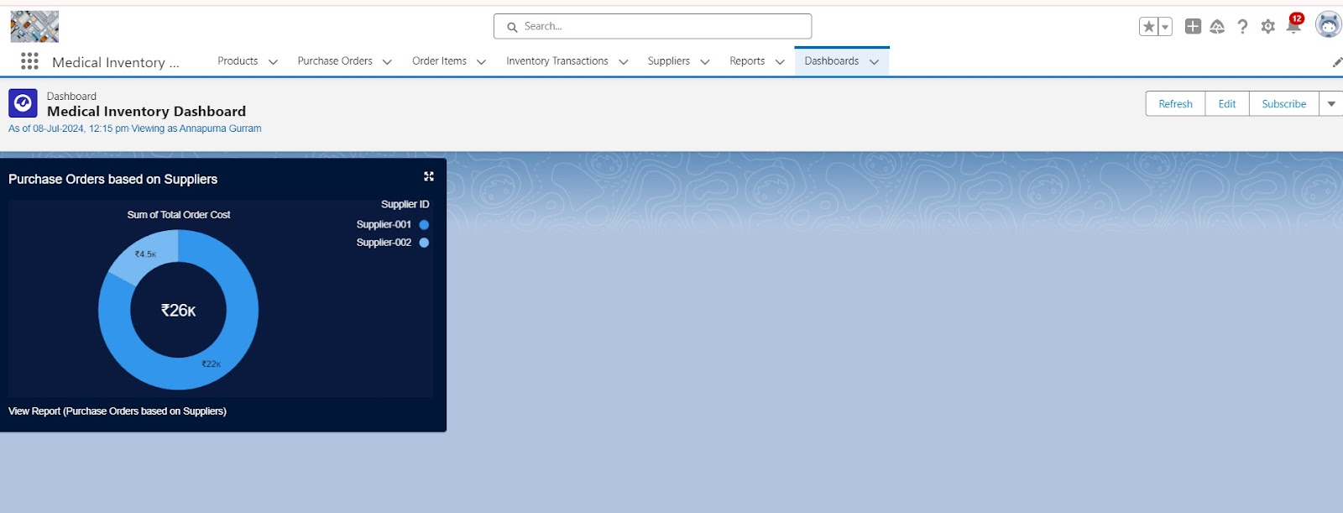

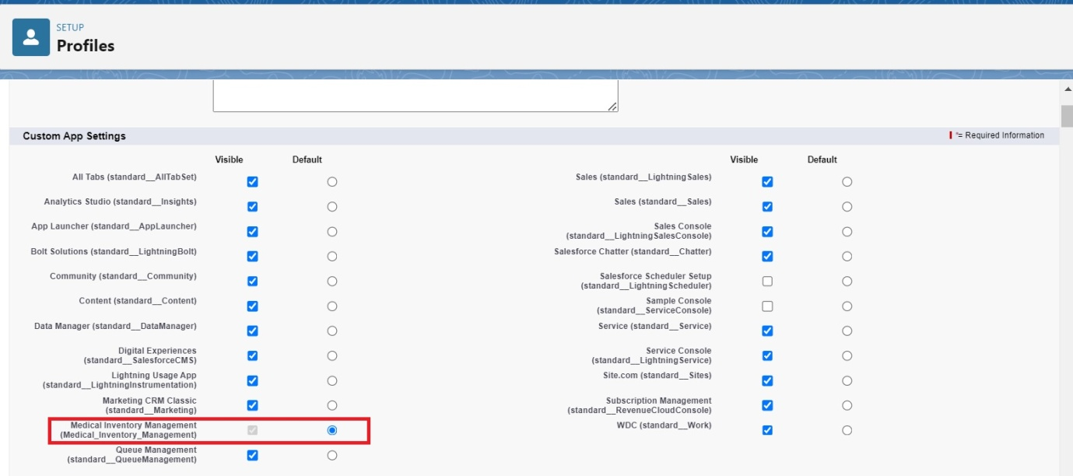

**Apex Handler**

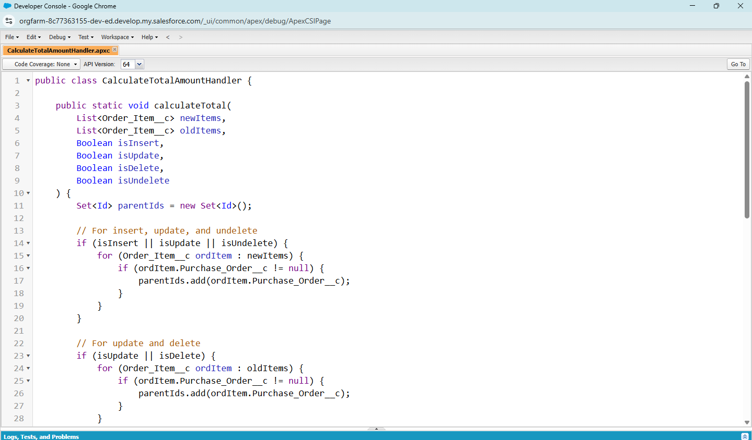

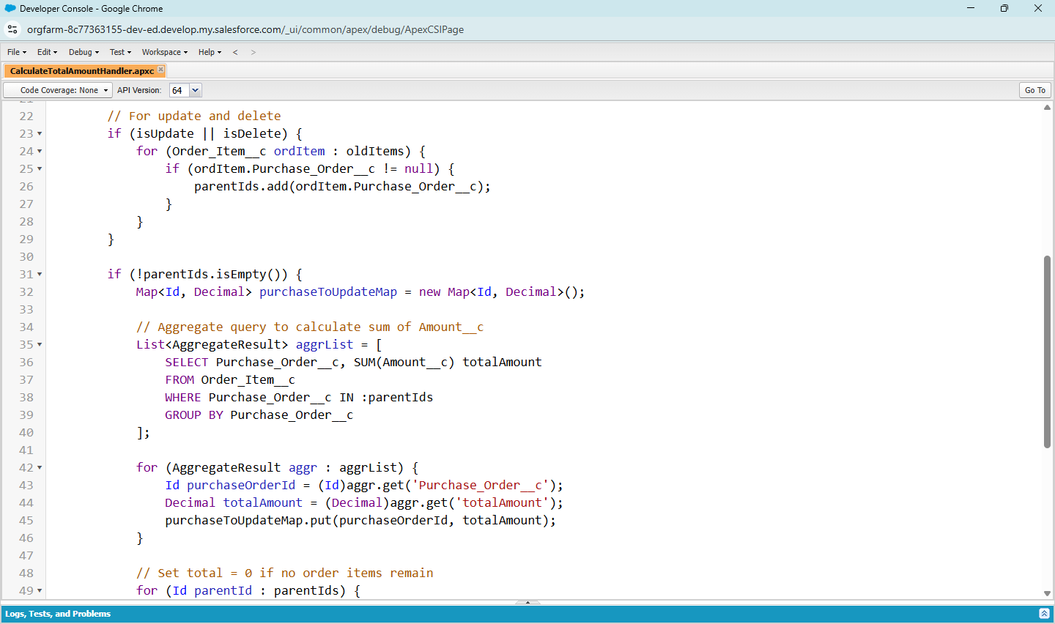

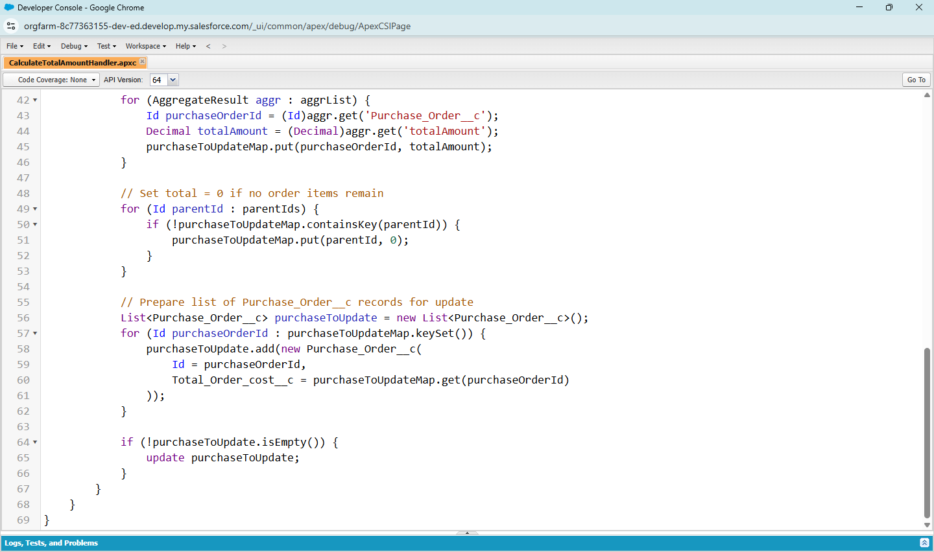

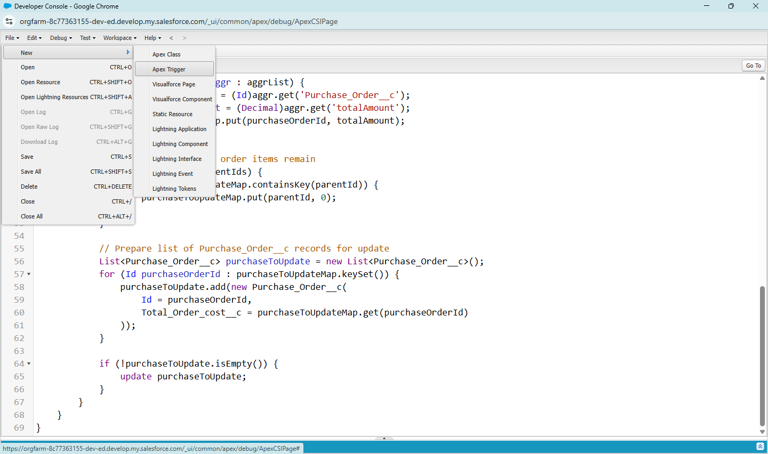

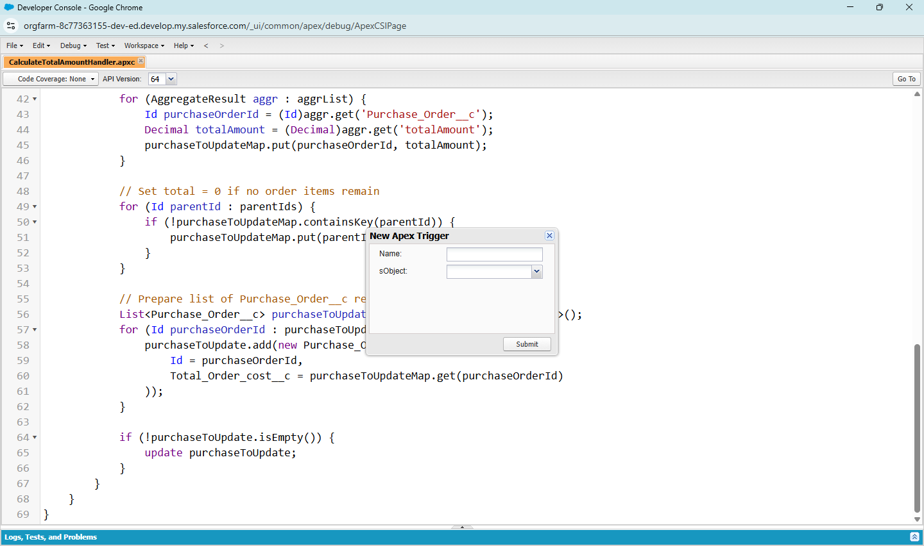

**Conclusion :**

The **Medical Inventory Management System** improves efficiency in managing medical supplies by automating stock monitoring, expiry tracking, and supplier coordination. It ensures real-time availability of medicines, reduces wastage, and supports better decision-making for healthcare providers. The system enhances **efficiency, transparency, and patient safety** in medical operations.

**Appendix:**

* **Source Code:** Provided in Apex Classes and Triggers
* **Objects Used:** Inventory, Supplier, Purchase Order
* **Automation Implemented:** Expiry check, Low-stock alerts, Reorder triggers.

**Apex handler :**

public class CalculateTotalAmountHandler {

public static void calculateTotal(

List<Order_Item__c> newItems,

List<Order_Item__c> oldItems,

Boolean isInsert,

Boolean isUpdate,

Boolean isDelete,

Boolean isUndelete

) {

Set<Id> parentIds = new Set<Id>();

// For insert, update, and undelete

if (isInsert || isUpdate || isUndelete) {

for (Order_Item__c ordItem : newItems) {

if (ordItem.Purchase_Order__c != null) {

parentIds.add(ordItem.Purchase_Order__c);

}

}

}

// For update and delete

if (isUpdate || isDelete) {

for (Order_Item__c ordItem : oldItems) {

if (ordItem.Purchase_Order__c != null) {

parentIds.add(ordItem.Purchase_Order__c);

}

}

}

if (!parentIds.isEmpty()) {

Map<Id, Decimal> purchaseToUpdateMap = new Map<Id, Decimal>();

// Aggregate query to calculate sum of Amount__c

List<AggregateResult> aggrList = [

SELECT Purchase_Order__c, SUM(Amount__c) totalAmount

FROM Order_Item__c

WHERE Purchase_Order__c IN :parentIds

GROUP BY Purchase_Order__c

];

for (AggregateResult aggr : aggrList) {

Id purchaseOrderId = (Id)aggr.get('Purchase_Order__c');

Decimal totalAmount = (Decimal)aggr.get('totalAmount');

purchaseToUpdateMap.put(purchaseOrderId, totalAmount);

}

// Set total = 0 if no order items remain

for (Id parentId : parentIds) {

if (!purchaseToUpdateMap.containsKey(parentId)) {

purchaseToUpdateMap.put(parentId, 0);

}

}

// Prepare list of Purchase_Order__c records for update

List<Purchase_Order__c> purchaseToUpdate = new List<Purchase_Order__c>();

for (Id purchaseOrderId : purchaseToUpdateMap.keySet()) {

purchaseToUpdate.add(new Purchase_Order__c(

Id = purchaseOrderId,

Total_Order_cost__c = purchaseToUpdateMap.get(purchaseOrderId)

));

}

if (!purchaseToUpdate.isEmpty()) {

update purchaseToUpdate;

}

}

}

}